**BScCM Final Year Project 2022 – 2023**

**Phase I Final Report**

| **<< Group Name: EVA ; Group No.: 37** **>>** |
| --- |
| **<< The Mirror Forest >>**   **Student Name/EID : TAM, Tsun Kin (56226942)**  **Student Name/EID : WONG Wai Lam, Antonio (56223595)**  **Student Name/EID : LAI, Chun Wai (56211836)**  **Programme Code : SM4712B**  **Supervisors SCM : Ms. YIP, Koala Choi Fung**  **CS : Dr. Chan, Wing Kwong Ricky**  **Date : 9/12/2022 1/5/2023** |

**Table of Contents**

1. **Introduction**
2. **Objectives**
3. **Deliverables**
4. **Work Plan**
5. **Background Research Survey**

* **About self-reflection**
* **About Installation (in idea and artist way)**

1. **Framework**
2. **Methodology**
3. **Implementation and evaluation**
4. **Discussion and analyse/Data collection**
5. **Concluding remarks: A critical appraisal of the project**
6. **Summary**
7. **Acknowledgements**
8. **References/Appendices**
9. **Appendices: Relevant information listing all support material**

# 

# **Introduction**

In this report, we'd like to examine the value of self-reflection and offer our idea as an installation art. According to the report released, we refined the concept and concluded that the moving mirror is the key part, with music and other multi-sensory and multi-angle elements being added to give participants an immersive experience.

Based on the results, we defined the concept of self-reflection, established the viability of the mirror installation, and found examples of related works. Following a series of preliminary tasks, we chose the development path and carried out more testing. The purpose of this prototype is to test out the mirror's main features.We can determine whether we can achieve our criteria and confirm its practicality by building and showing the key features.

Before implementing the plan, we prepare the materials and have a confirmed plan. The installation was built step by step following the idea, including a large number of mirrors and the development of functions. During the producing process, we record the problems encountered and the solutions, break down the core obstacles, and achieve the maximum production within the time limit.

Finally, after the completion of the installation, we conducted a review and summed up the experience to strive for progress.

# **Objectives**

Nowadays, youth rarely have the chance to speak with themselves due to a lack of self-reflection. As college students, we also have this issue. Students at college must deal with challenges related to their job, education, interpersonal interactions, etc., yet their self-awareness is still developing. We experience confusion and stress due to external pressure occasionally, but we cannot find relief from these feelings or a fix for these issues in the internal conflict. The extent of external force is influenced by how we process and comprehend ourselves, as we discover when we look inward and study people around us. But we hardly ever confront our thoughts and even avoid confronting our true selves. Although we can observe these phenomena, we do not have the essential way to comprehend them. Nevertheless, does this circumstance represent a general phenomenon or an isolated case? No one knows. Therefore, data collection is needed and will be presented in this report. And hopefully, we can assist people in self-reflecting with our installation.

Teenagers' self-construction has long been a significant social issue, and even secondary schools offer lessons covering this topic. Through our research, we can find the causes, effects, and solutions which will benefit us when we create the installation by understanding the target audience.

**The installation has several objectives:**

**Objective 1:** Providing a tool for visitors to face themselves.

**Objective 2:** Guiding visitors to think about their own problems.

**Objective 3:** Instilling the statement: “Your internal feelings are way more important than how others see you.”

**Objective 4:** Accepting your flaws. No one is perfect.

# 

# **Deliverables**

The installation requires an open environment and free space to prevent intrusion and influence from the surroundings. The installation includes different domains and functions. People gradually become a part of the work's internal universe through movement, sound, and vision.

The moving mirror is the first and main visual aspect of the piece. It is placed at the extremity of the area, hanging on the wall. It comprises several little mirrors that combine to make one large mirror. The mirror will tilt in various directions, following the viewer's movements, and tiny mirrors will reflect the viewer's appearance as it appears from each direction. The participants can see themselves reflected from various angles from their perspectives in addition to the mirror moving with them. It gives the participants a familiar and foreign visual effect by reflecting human faces at densely packed and various angles.

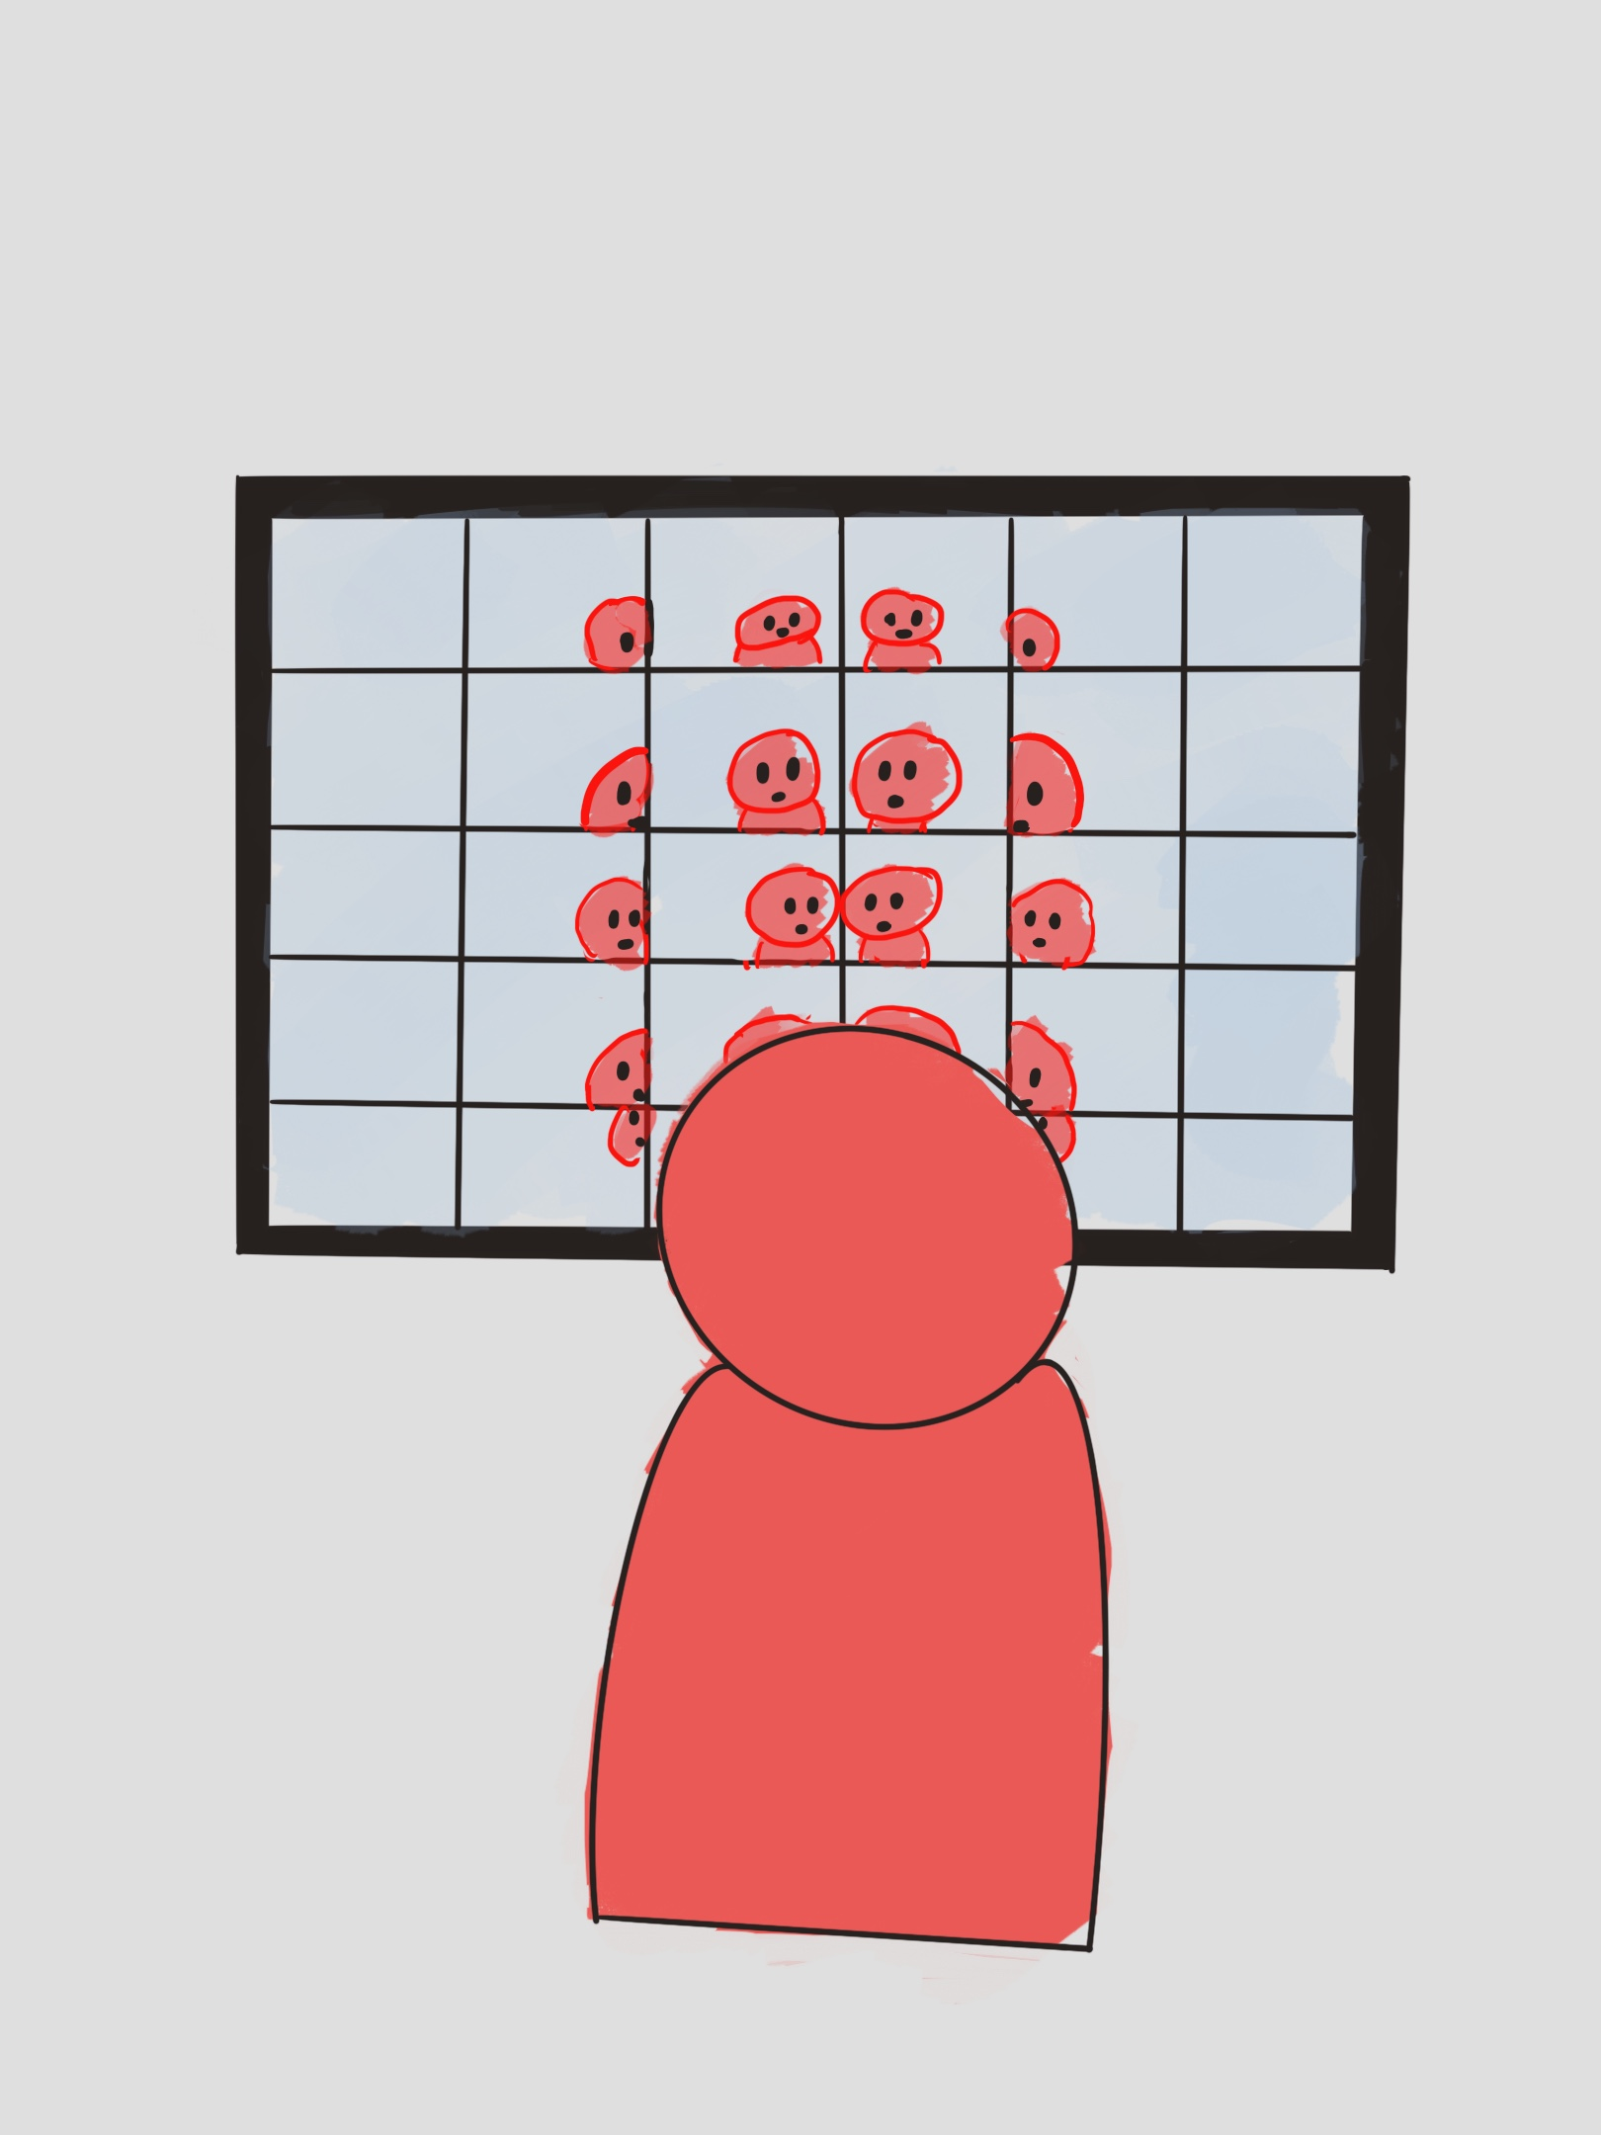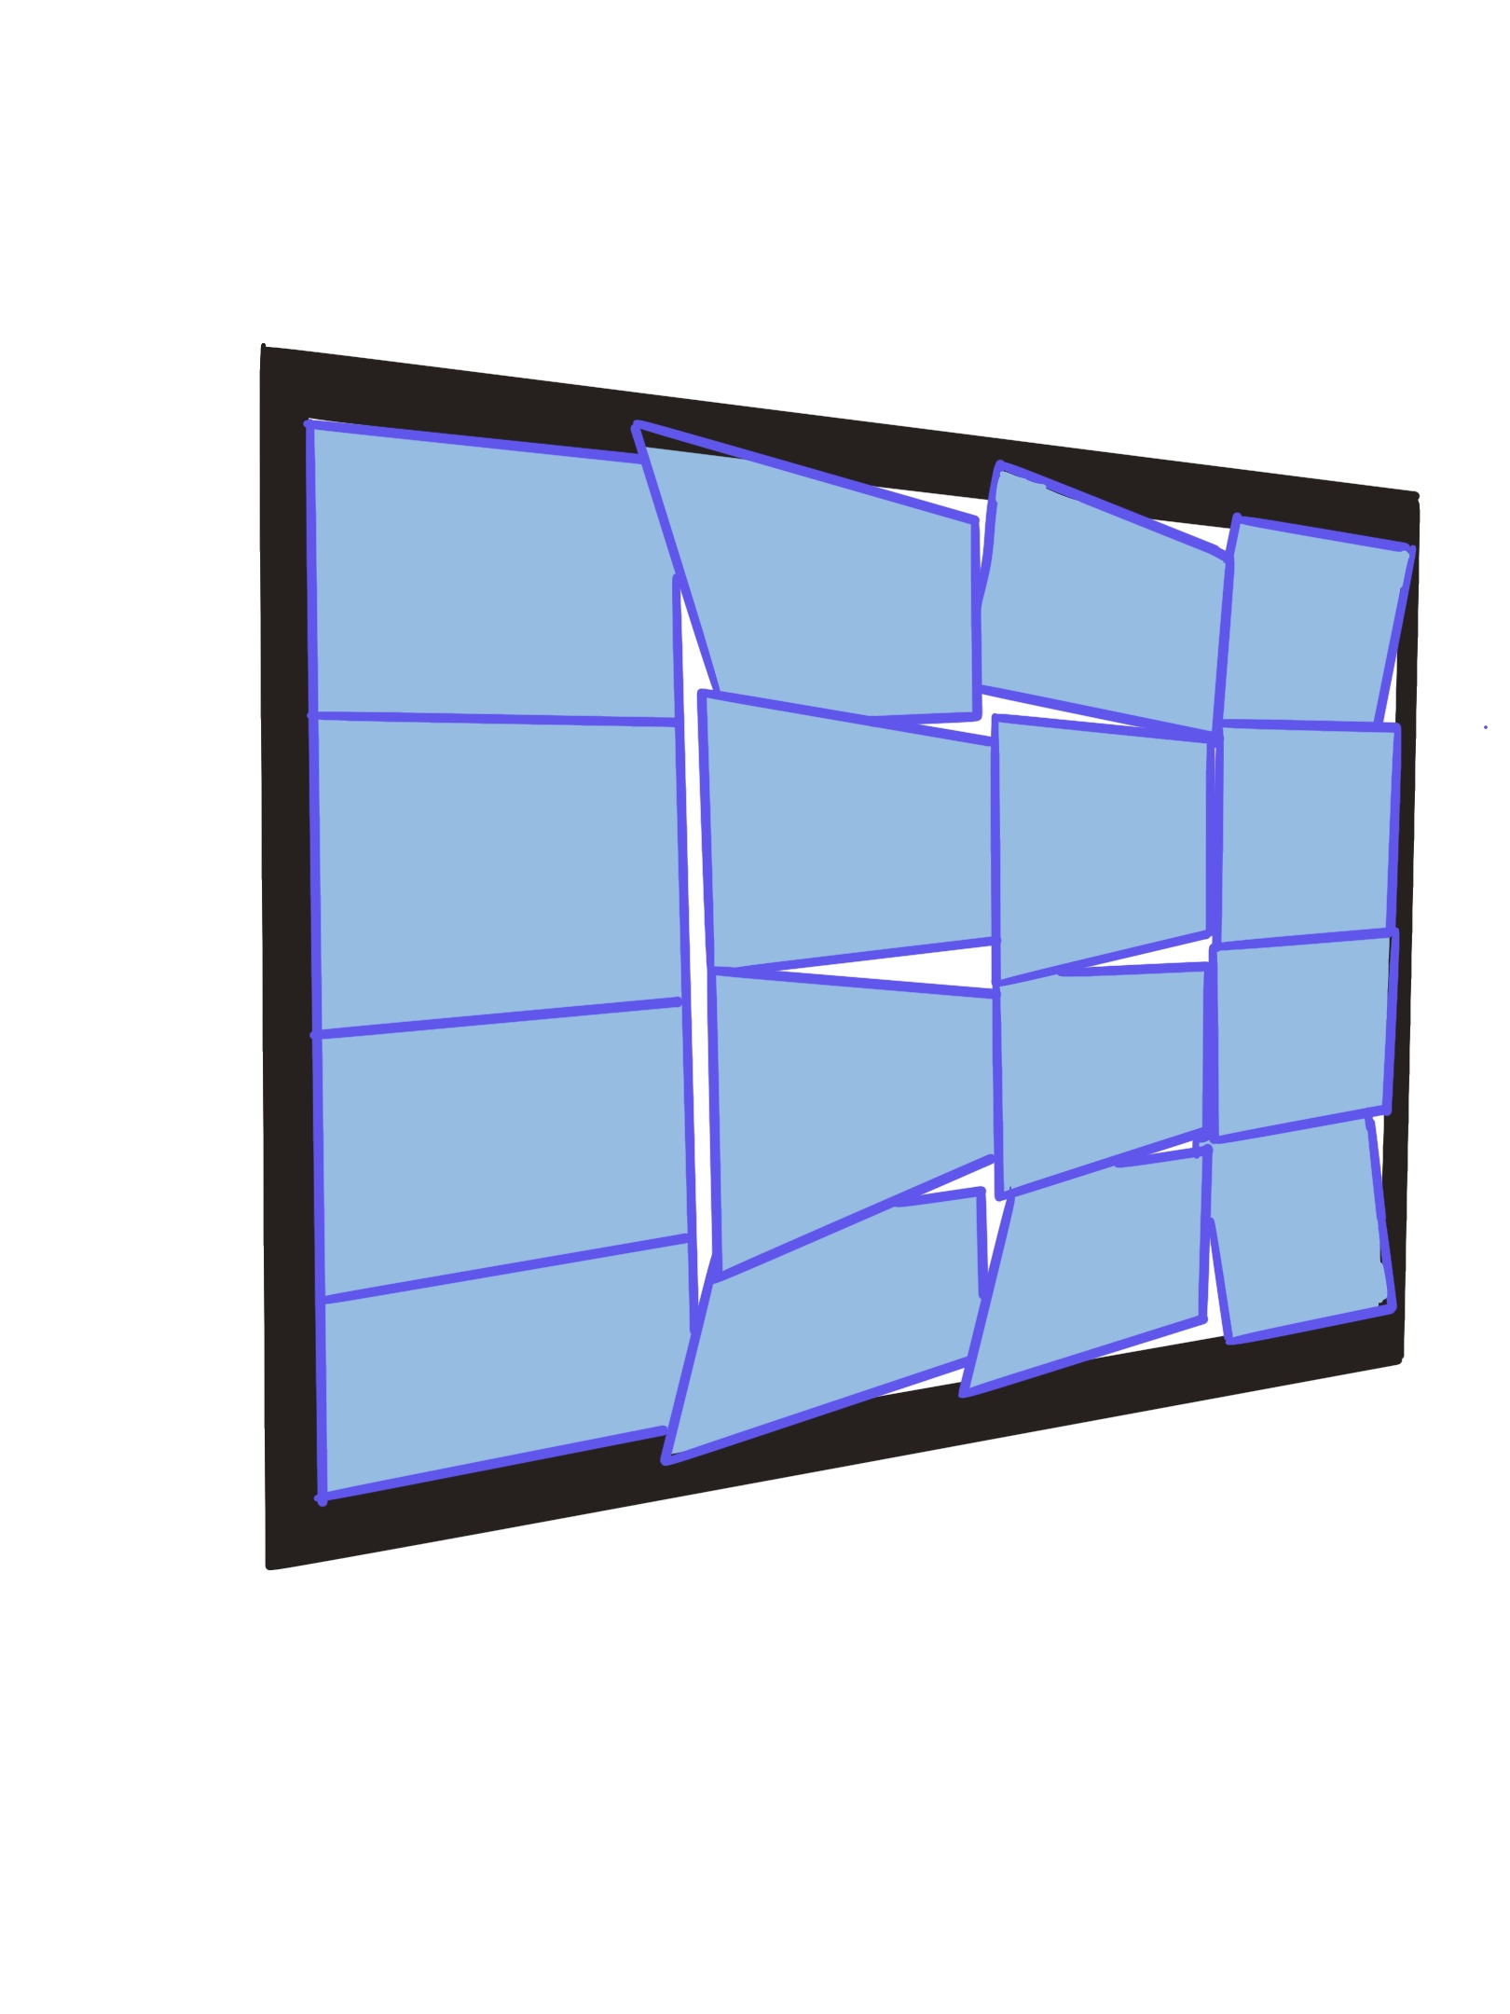

To create a forest of mirrors, additional mirrors will be present throughout the surrounding space of the installation. They will be placed in various configurations around the area. The visual representation of the mirror includes multiple shapes to reflect the participants' entire bodies. Mirrors of different shapes reflect various limbs. For instance, the mirror may be warped to depict an exaggerated and fat body shape, expressing negative labels or the lack of social acceptance and support for such individuals. Participants can see their bodies in the mirror's reflection, as if the mirrored pictures of various shapes blend with them, changing the participants' body type, attire, attitude, etc.

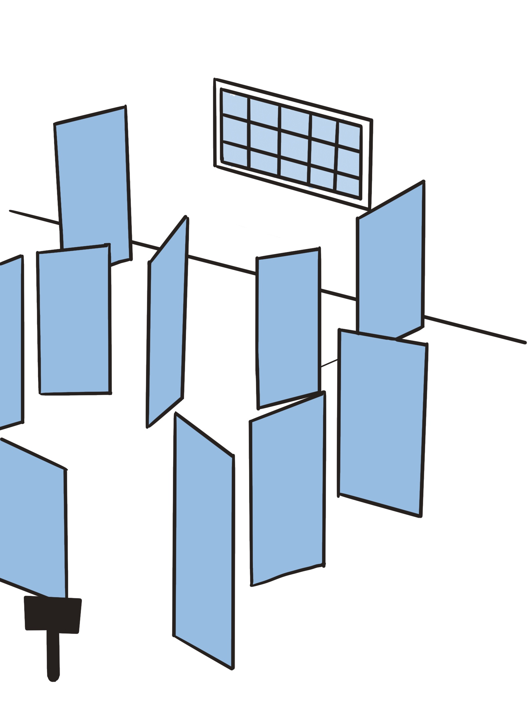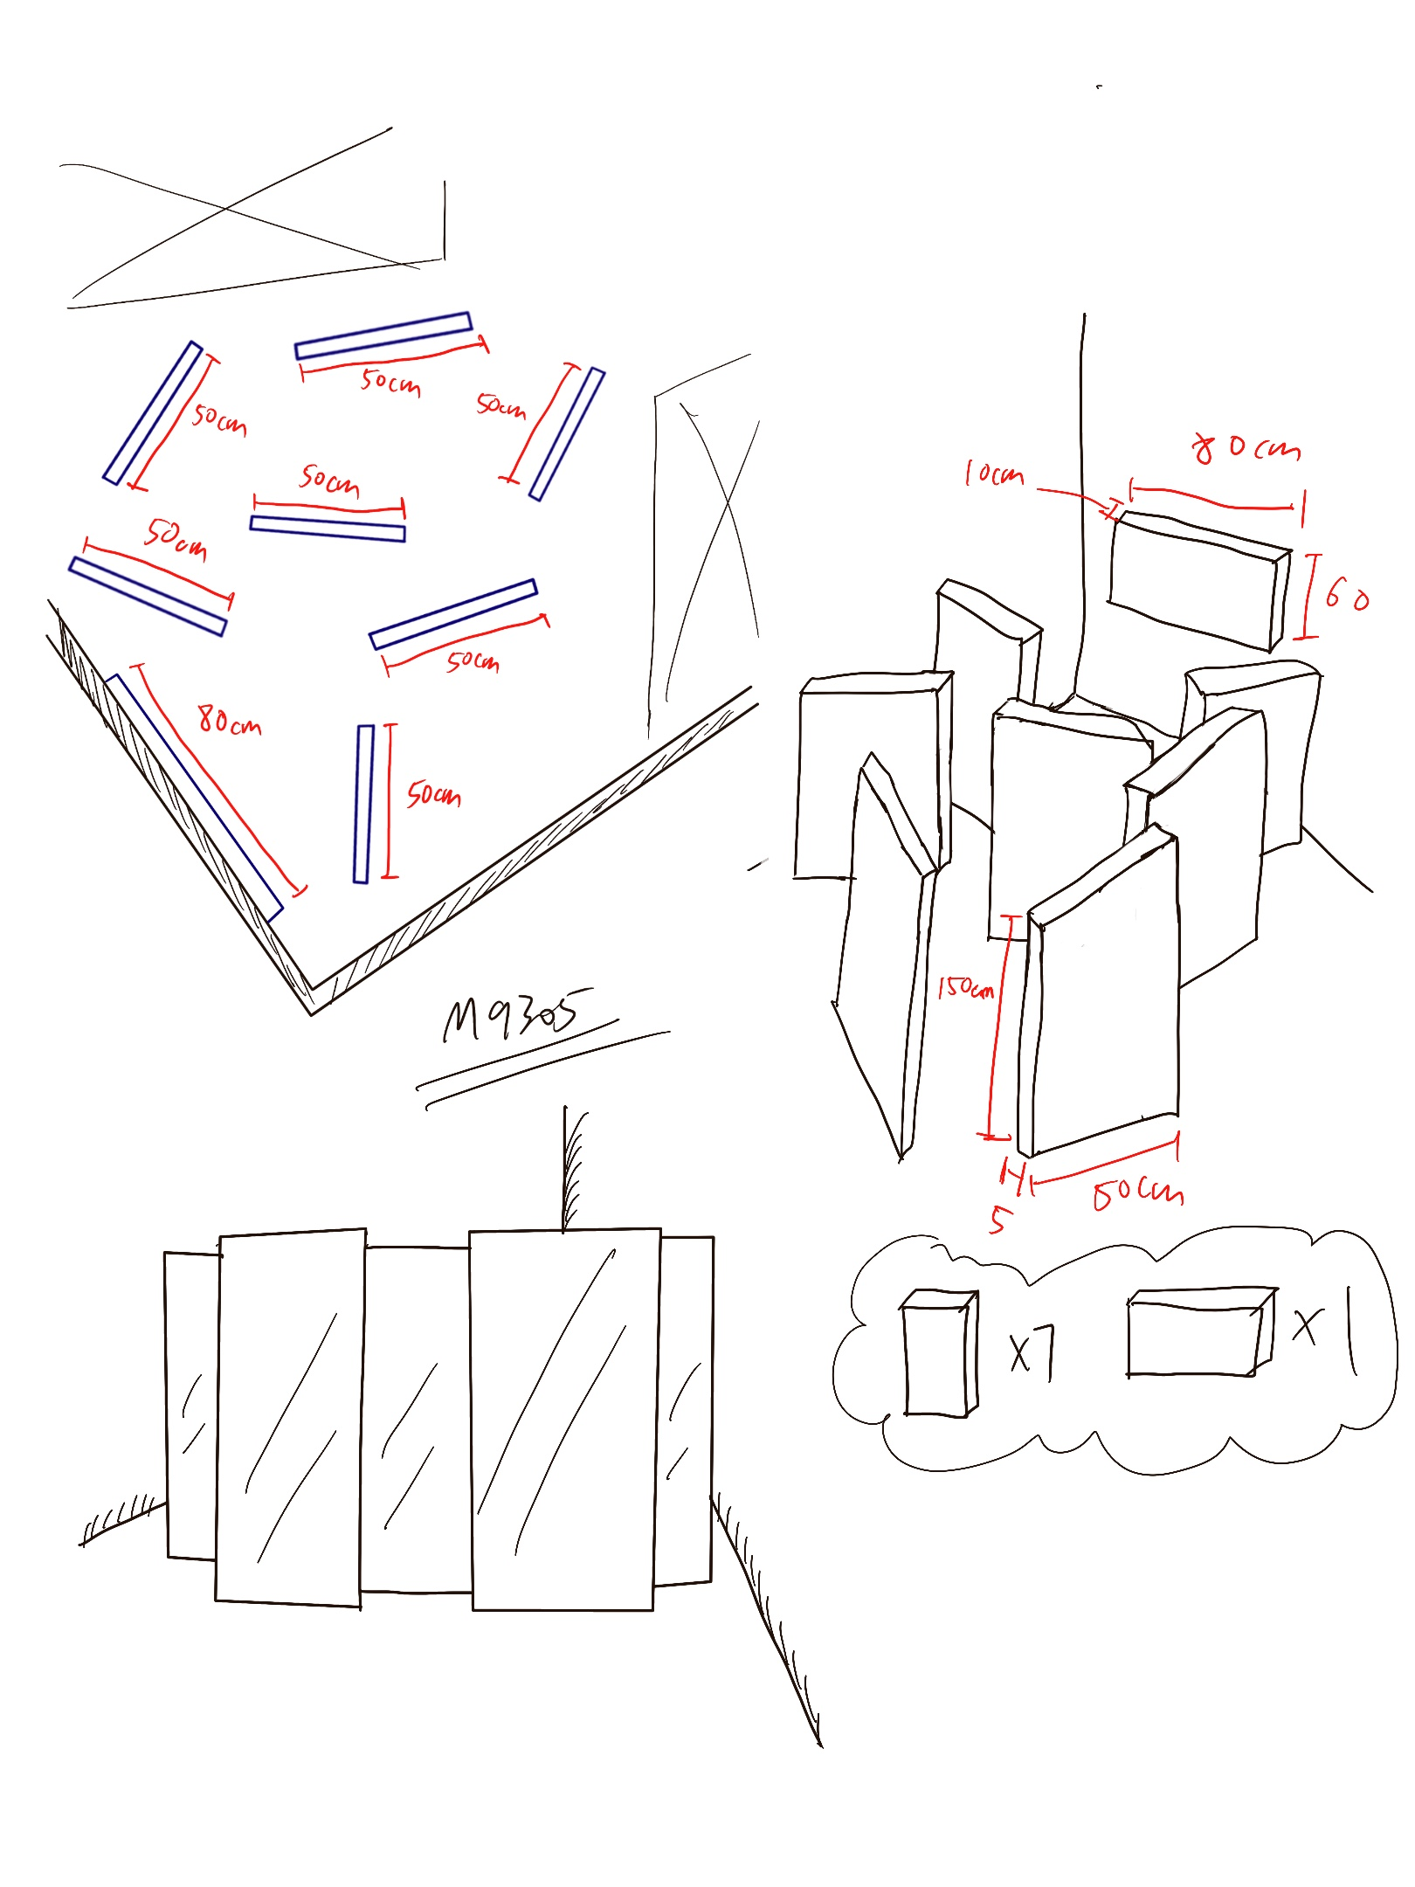

We finalise the idea is the structure refers to Stonehenge, and surrounds a space in the order of arrangement and then puts the most surprising part in the middle to create importance. The mirror will be made into different shapes to bring out different messages.

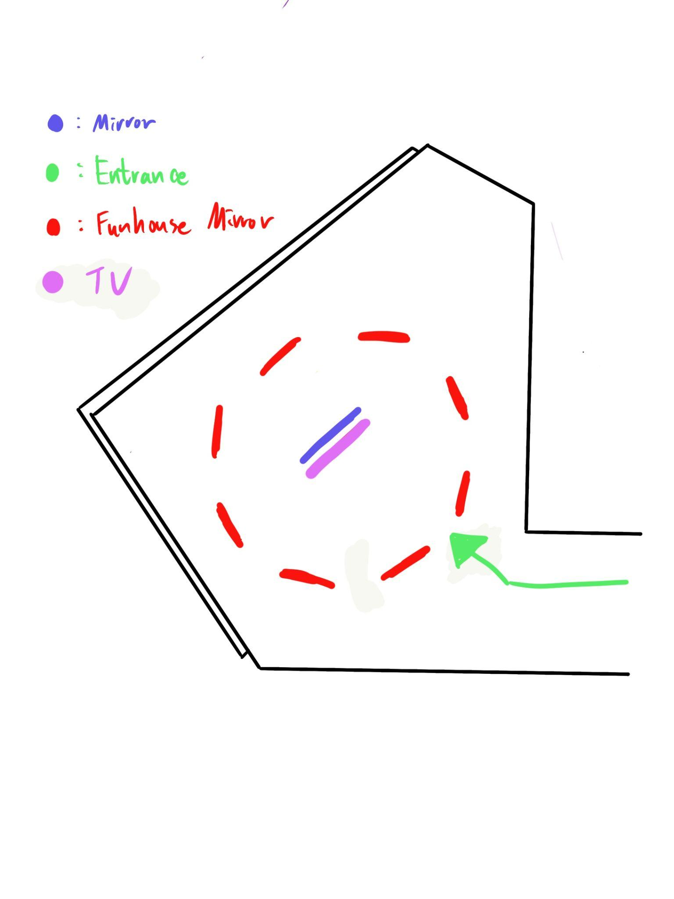

# 

# **Work Plan**

| **2022 -2023** | **JUL** | | **AUG** | | **SEP** | | **OCT** | | **NOV** | | **DEC** | | **JAN** | | **FEB** | | **MAR** | | **APR** | | **MAY** | | **JUN** | |
| --- | --- | --- | --- | --- | --- | --- | --- | --- | --- | --- | --- | --- | --- | --- | --- | --- | --- | --- | --- | --- | --- | --- | --- | --- |
| Idea consolidation |  |  |  |  |  |  |  |  |  |  |  |  |  |  |  |  |  |  |  |  |  |  |  |  |
| Present to advisors |  |  |  |  |  |  |  |  |  |  |  |  |  |  |  |  |  |  |  |  |  |  |  |  |
| Research |  |  |  |  |  |  |  |  |  |  |  |  |  |  |  |  |  |  |  |  |  |  |  |  |
| Research Report |  |  |  |  |  |  |  |  |  |  |  |  |  |  |  |  |  |  |  |  |  |  |  |  |
| Prototype |  |  |  |  |  |  |  |  |  |  |  |  |  |  |  |  |  |  |  |  |  |  |  |  |
| Final Report |  |  |  |  |  |  |  |  |  |  |  |  |  |  |  |  |  |  |  |  |  |  |  |  |
| Improvement on project |  |  |  |  |  |  |  |  |  |  |  |  |  |  |  |  |  |  |  |  |  |  |  |  |
| Code testing |  |  |  |  |  |  |  |  |  |  |  |  |  |  |  |  |  |  |  |  |  |  |  |  |
| Reports |  |  |  |  |  |  |  |  |  |  |  |  |  |  |  |  |  |  |  |  |  |  |  |  |
| Final Present and demo |  |  |  |  |  |  |  |  |  |  |  |  |  |  |  |  |  |  |  |  |  |  |  |  |

# 

# 

# 

# **Background Research Survey**

We will divide the research into two parts. The former part will concentrate on young people's self-awareness from a broad perspective, from the micro to macro level, and followed by similar projects (on both the idea and presentation format) that have been done by other artists in the latter part.

## **About Self-reflection**

1. **The looking-glass self**

First of all, there is a fact that we cannot deny: the construction of the self cannot eliminate external social variables. The "looking-glass self" refers to the method through which people construct a sense of self-based on how they believe others perceive them. People utilize interpersonal relationships as a sort of "mirror" in order to compare their own beliefs, principles, and actions to those of others. Humans and society are complementary facets of the same world rather than being two separate occurrences. Therefore, it is necessary for others to assess how the self is formed. Teenagers gauge their character through others, including teachers, classmates, parents, and the social environment.

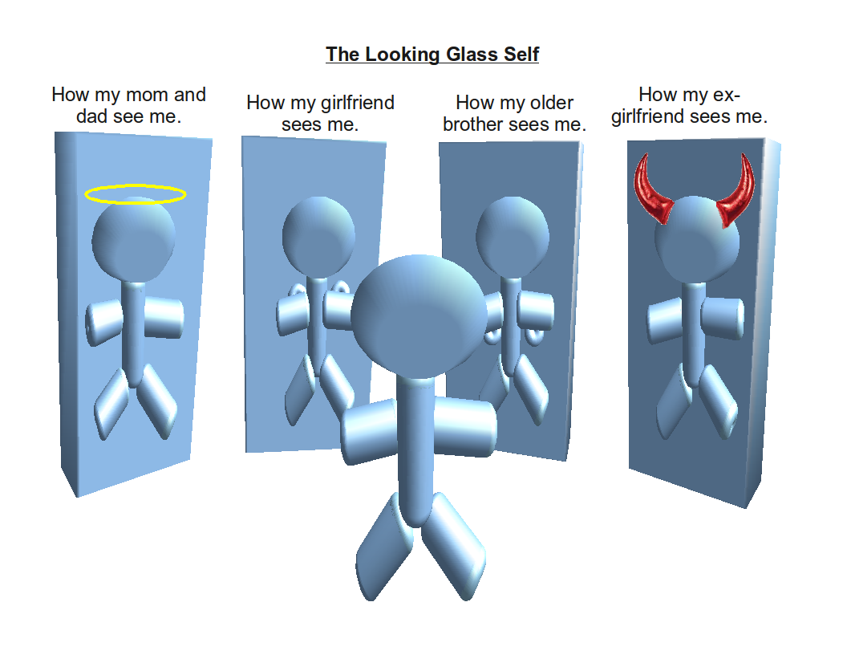

1. **Labelling**

The judgment of others is necessary for the development of the self, and the appraisal and compelled categorization of social groupings or people is known as labeling. Understanding how others (such as authority figures) view a person through social interactions allows one to develop and remodel their personal identity constantly.

Primary deviation and secondary deviation are the two different kinds of labeling. The term "primary deviation" describes the occurrence of people's initial, inconsequential behavioral behaviors, which are influenced by various social, cultural, and psychological factors. Status and self-image were not further impacted by primary deviation. We rationalize and disregard labels rather than using prejudices to define who we are. It cannot alter young people's thinking, and primary deviation in labeling will not have any external effects.

The secondary deviation is the more severe and pervasive violation, which really impacts them. Stigma is produced when shame becomes an identity. It results in young people being labeled, and through a variety of perspectives and elements. It instills in them the traits of this label, causing them also to become this label. And they are troubled by this society-contaminated self. They will have self-doubt and cause a chain reaction of dissatisfaction. This type of pressure is unhealthy for them and hinders the growth of accurate self-awareness.

1. **Id, ego, and superego**

According to psychologist *Freud*, the id, ego, and superego are the three main components of the spirit and form the basic consciousness. The most inaccessible and highly primal aspect of personality is the id, which is composed of all innate intuitive impulses. It includes human instinctual urges and suppressed tendencies, in which all instinctive impulses are guided solely by the "pleasure principle" and blindly chase satisfaction. These impulses have no concept of logic or morality.

The conscious aspect of the personality is known as the ego. It is a system of perception developed from the id under the outside world's impact and was distinguished from the id by repeated lessons from reality. The factual principle serves as a guide in this section in order to both achieve satisfaction and prevent discomfort. The ego regulates the id and superego and is in charge of maintaining contact with reality. It can both satisfy the superego and watch over the id.

The superego is the moralized ego, the personality's final and most civilized aspect. The ego stands out from the ego and is capable of self-criticism. The superego reflects the moral expectations and behavioral norms of the culture in which the child grows up. The id and its moral regulation function directly and violently in opposition to one another.

And there are three levels to the ego. The first is our actual selves, which are reflections of our present circumstances. Then there is the ideal self, which reflects our aspirations and references our hopes. People's ideal selves are the attributes, traits, and traits that people wish they had or could have, but which do not exist in the present. The perceived self is the last one, and it deals with obligations and responsibilities that we personally feel we should take on. We will comprehend the circumstances and make this our objective by looking at these three separate selves.

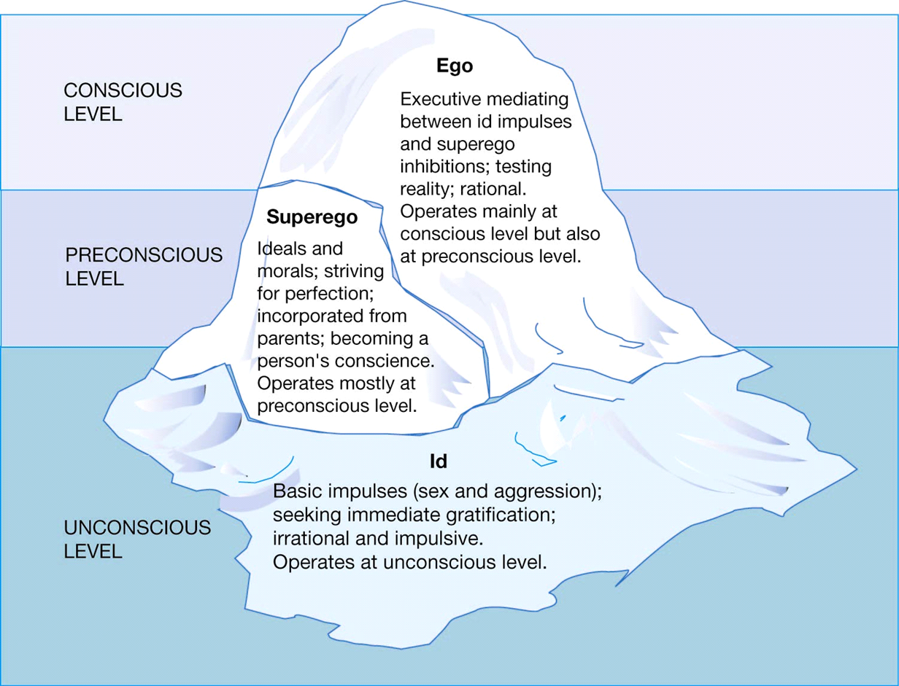

1. **Self-reflection**

One must engage in self-reflection if one wishes to comprehend who he/she is. Individuals may vary in the degree to which they relive the emotions and sentiments that the unfavorable experience first sparked during self-reflection. While suppressing emotions is frequently linked to negative affectivity and physical arousal, expressing emotions is regarded as a constructive statement of the self in autonomous circumstances. In order to express their emotions and reflect on how they were shaped by both internal and external circumstances, we must lead the participants in this effort toward self-reflection.

## **About installation**

Regarding the presentation media: installation, we will analyze the research in the idea and artistic aspect. For the idea part, similar installations about self-exploration will be explored while installations made with mirrors will be explored on the artistic part.

**Idea:**

1. ***Vanishing Reflection* by *Olafur Eliasson***

By hanging a mirror on the wall, *Olafur Eliasson* intends to create a “fade out” effect when visitors walk by. He states “You only see things when you move” in the introduction of the artwork, allowing visitors to reflect on the coherence of emergence and disappearance.

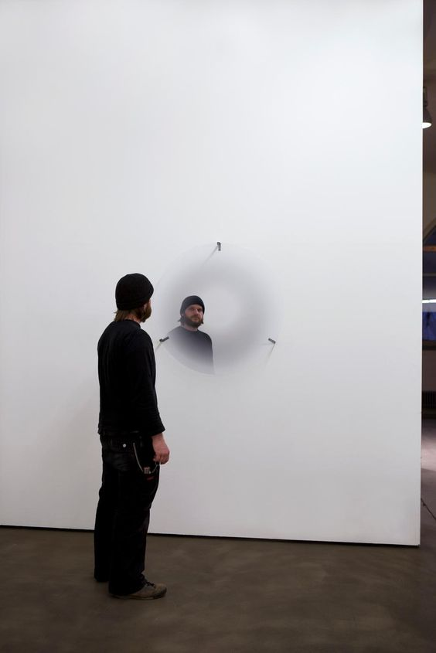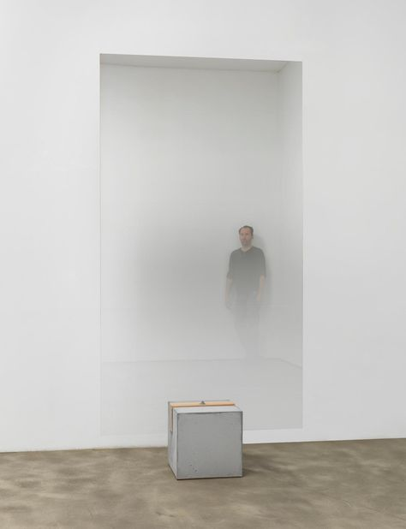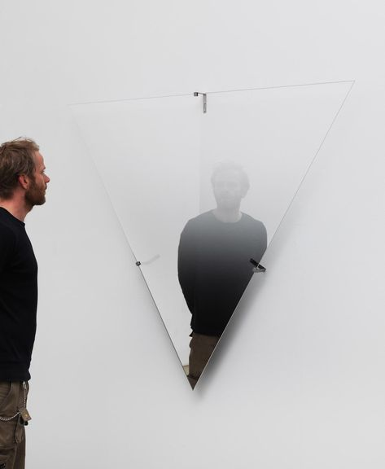

1. **“*Are You Really Here*” Series by *Jeppe Hein***

A project similar to ours, but using words and quotes directly to make people reflect. It is exhibited at Johann Köning Gallery in Berlin. Visitors can experience a series of digital screens popping up sentences and questions while walking by.

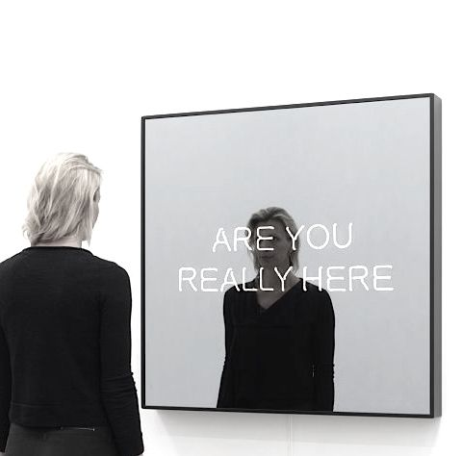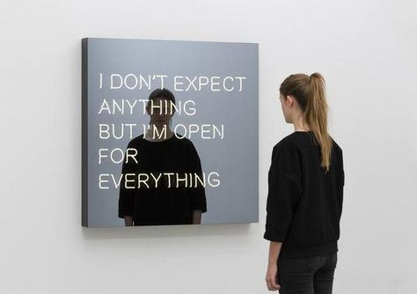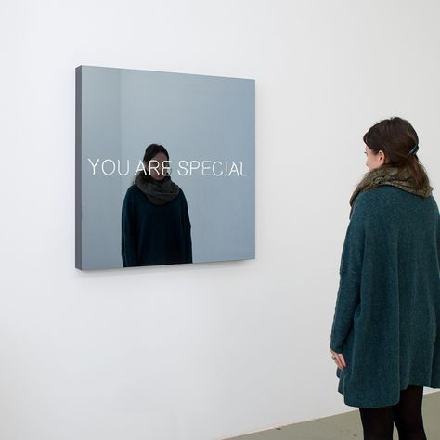

**Artistic:**

1. **Mirror as a path**

The installations below use mirrors to build a “road” for people to walk past. The left one is *Room 2022* by *Es Devlin*. It spans over 7,000 square feet and takes visitors on a psychedelic journey that features color-saturated corridors, trick doors, and a vaulted elliptical mirror maze. The space is a playground for the imagination—where visitors perceive one another in fragments over sliced walls and reflected inverted in mirrored ceilings. The right one is *Path of Silence* by *Jeppe Hein*. It is intended to encourage visitors to clear their minds and be present with the different kinds of silence from their surroundings. A labyrinth of mirrors encloses the sculpture's three spaces of silence marked by contemplation, expressed through a series of high mirror steles to draw the eye toward the sky.

Two installations demonstrate how a mirror can build a road/maze to lead visitors to immerse into their mirror world, by reflecting nature, or the fragment of others.

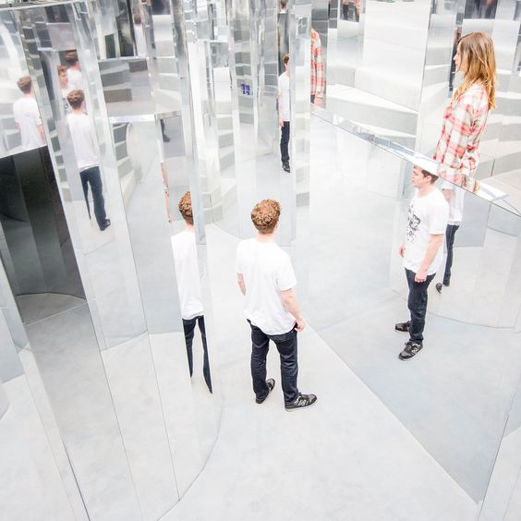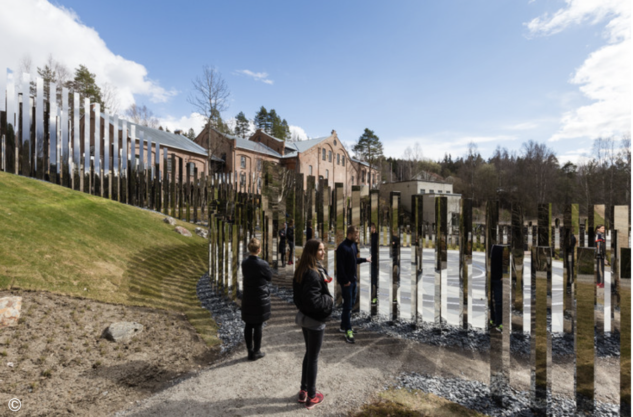

*Room 2022* by *Es Devlin*   *Path of Silence* by *Jeppe Hein*

1. **Mirror as a space**

Besides making a path, a mirror is usually used to create infinite space. The left one is *Dots Obsession—Aspiring to Heaven's Love* by *Yayoi Kusama*, one of the most influential and inspiring artists of our time. The artwork is an ambitious immersive environment for visitors to understand the artist's core concept of infinity and accumulation. The right is also from *Yayoi Kusama*, called *Infinity Mirrored Room.* It is a room through which visitors pass on a walkway made of mirrored tiles. The walls and ceiling of the room are also mirrored, and the floor surrounding the walkway is covered with a shallow pool of water. The pinpricks of light in the otherwise darkened room appear to reflect endlessly in the mirrors and the water, giving the viewer the experience of being in a seemingly endless space.

These two installations create an infinite space using mirror as the tool. It can be our reference for the immersive environment of our artwork.

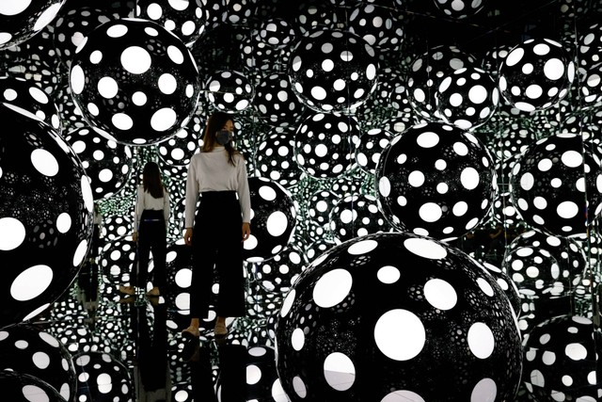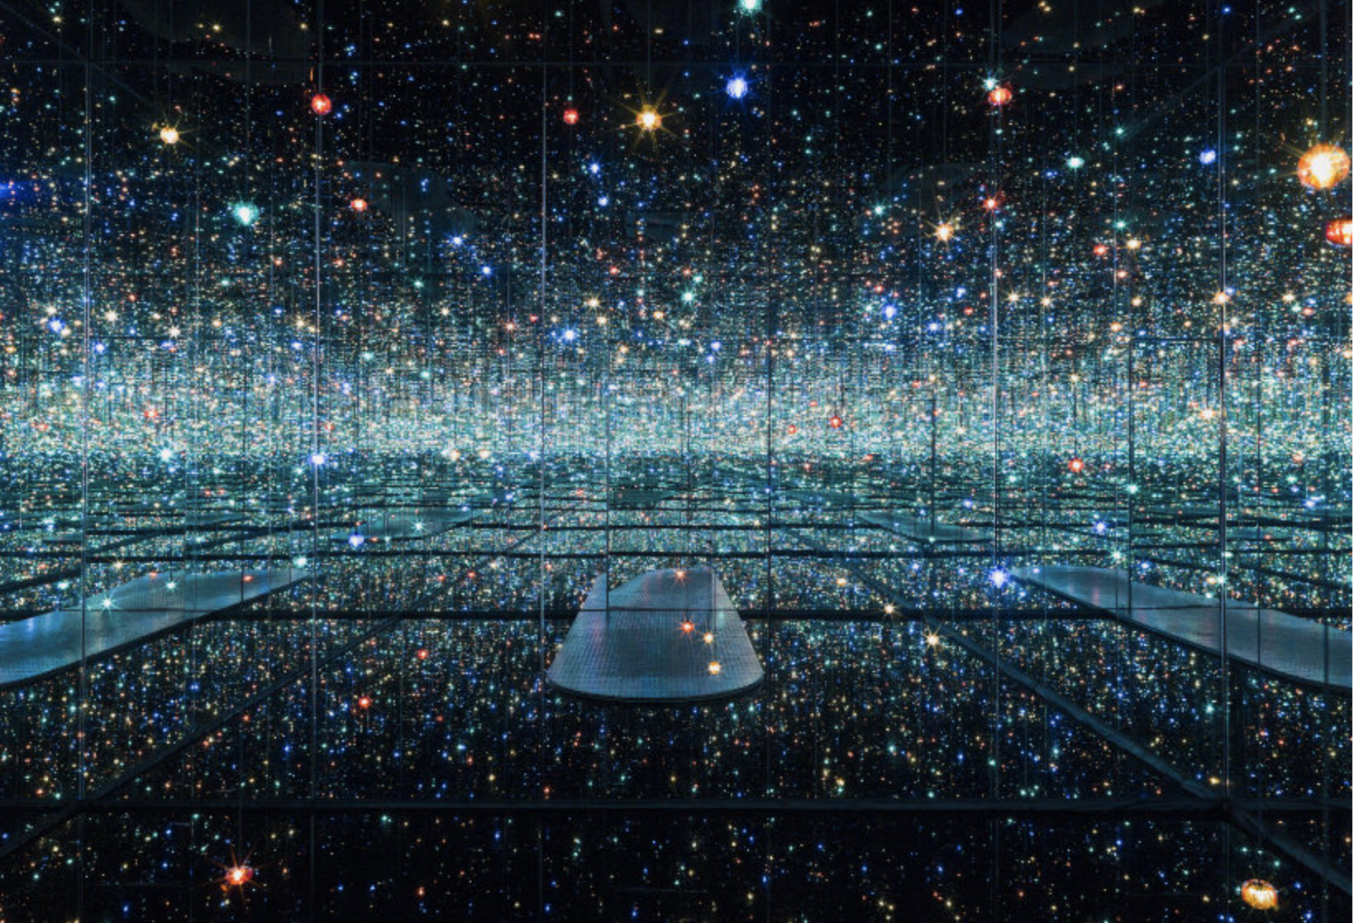

*Dots Obsession—Aspiring to Heaven's Love* *Infinity Mirrored Room* by *Yayoi Kusama*

# **Framework**

**Software overviews**

As we are doing interactive installation artwork, we decided to use Arduino as the main framework and languages to handle the mechanical parts of the work. For implementing the basic code, Arduino IDE software is mainly used to upload codes to the Arduino UNO board in order to control all the gadgets we use. In advance, VS code may be used to implement codes for further interaction with other programming languages such as javascript and python.

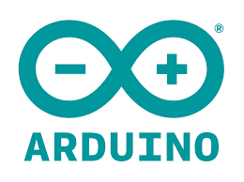

In our prototype, we tried to use multiple servos to control the movements of the mirror plates. The code we use is basically declaring variables and deciding how many degrees every servo has to turn when triggered through mapping values. Then constructing simple condition statements to define the timing of triggering them. In the prototype, we are now using a button to control the timing that servos move. In the future, we may try to implement an infra-red sensor, motion sensor, or even human face detection in Arduino or OpenCV. The following are the codes we used.

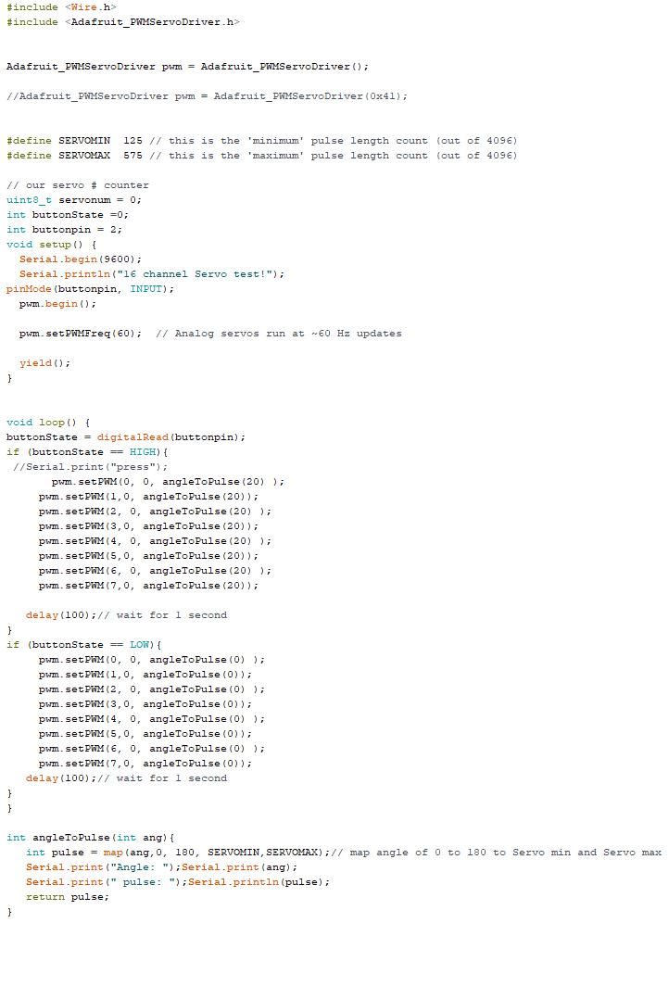

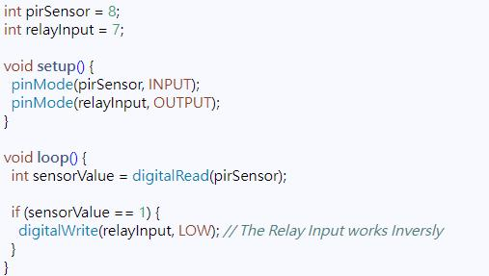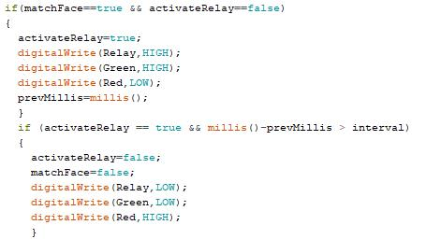

In the beginning, we tried to use the servo control code and function built in the Arduino library, but we realized afterward that it is impossible to connect too many servos on 1 Arduino board. Therefore we decided to use a PWM servos driver board to do it. In order to do it, we need to include the Adafruit library and use the analog pulse value to control it, so we decided to write a function that maps the pulse value with 0-180 degree values so that it can be understood and written easier. After matching, we found that for the SG90 servo, 20 degrees is the best to move.

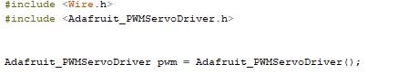

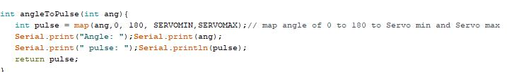

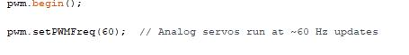

Using the built-in function and definition in Arduino to control the servo, the angle turned by each cannot be easily determined, also multiple servos more than 5/6 will be difficult. on the other hand with the help of the Adafruit library, each servo can be turned to the desired angle with pulse values matching to 0-180 degrees.

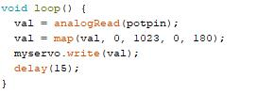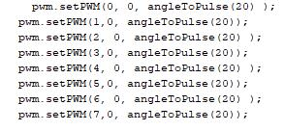

If we are going to implement face detection, we would like to control the servo motors to move according to the direction and position of the audience’s faces.

Besides that, we may consider creating more movement patterns of the whole mirror to follow the movement of the audience’s body.

# **Methodology**

Regarding the prototype , we decided to make a 3x3 plates version of the mirror to test out whether the idea and concept work.In order to construct a 3x3 version of the final mirror, the materials needed are “ 1x acrylic board,9x SG90 servos, 1x card board, 9x tripod heads for arduino, 1x roll of mirror reflection paper.

Firstly, we tested each sg90 servos to make sure they are mapped to 0-180 degree and also turning in the same direction.Then we combined all of them with the tripod heads for holding the back surfaces of those mirrors plates going to be attached later.About the tripod heads we were using in the prototype, they are not perfectly compatible with our work as they are not designed perpendicular to our plates, we only used tape to hold them and therefore not completely flat. We may consider using 3D printing to draw a custom one to fit it in the future.

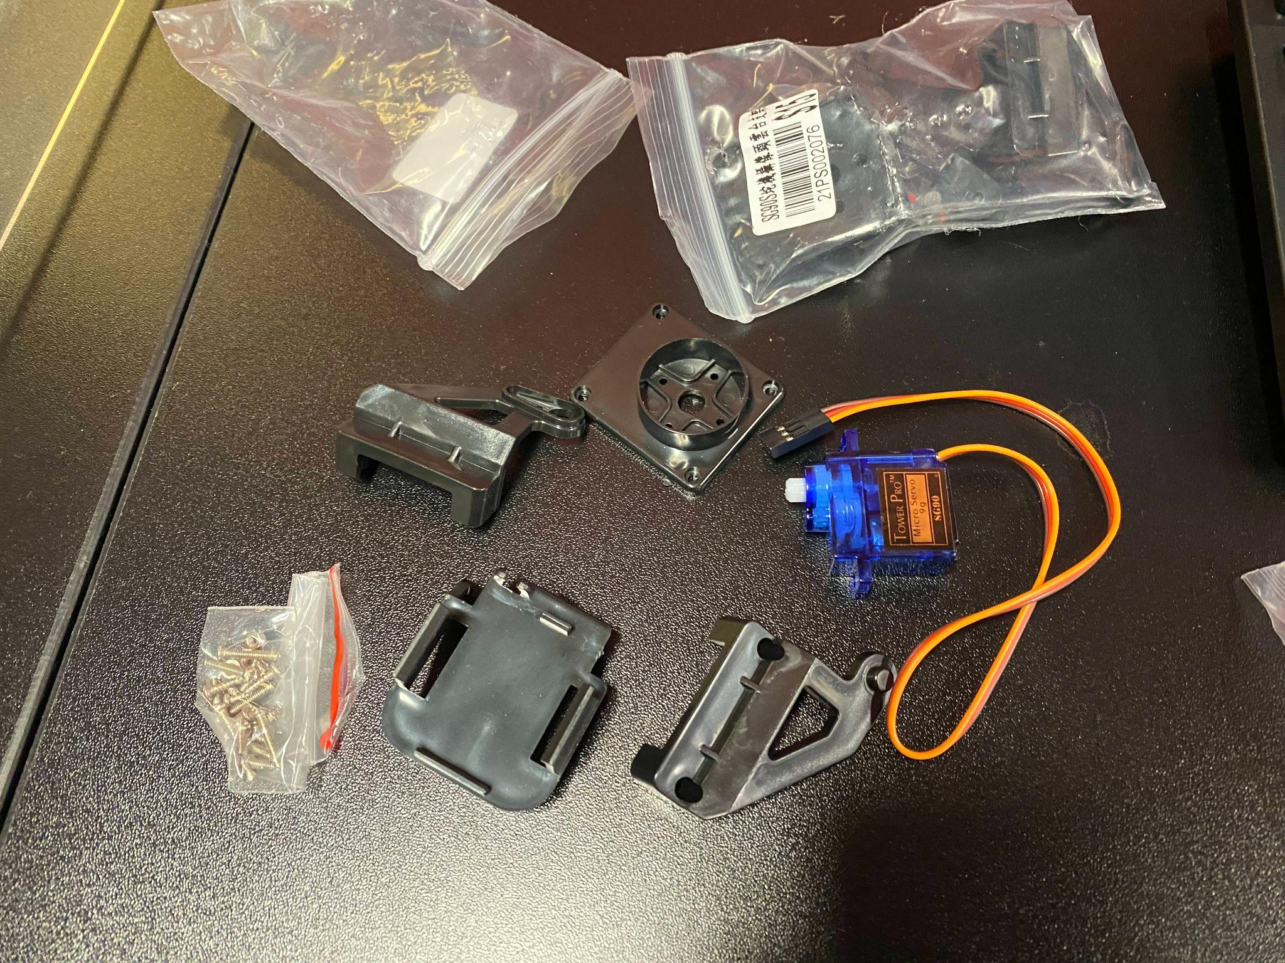

After that, we cut both the reflection papers and card boards in same size and

stuck them together to form a temporary “mirror plate”,about this, we have tried several kinds of mirror papers instead of a real one because we would like to reduce the weight so that the servos have enough power to control each .

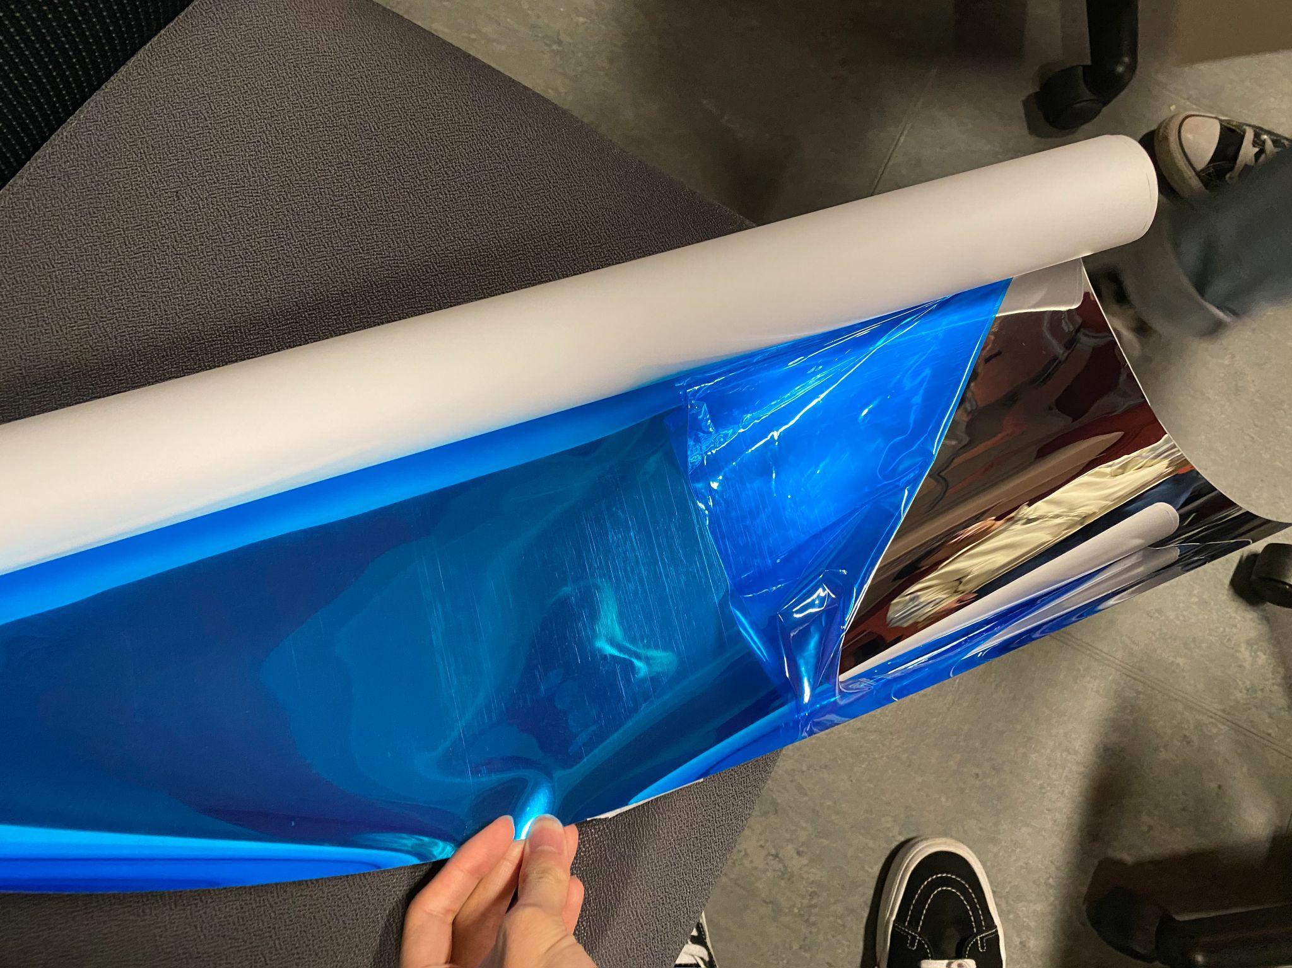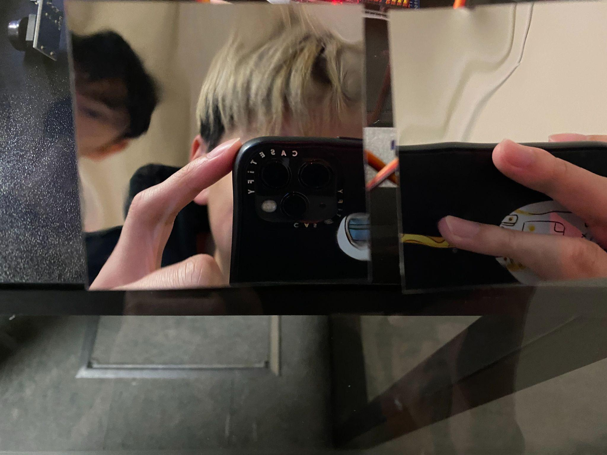

Finally , we attach the “mirror plate” on the tripod heads we assembled earlier to form the complete 3x3 mechanical mirror using arduino code to control.Besides, we have been discussing about the way to trigger the mirror to move in the prototype , face detection and infra-red recognition are two possible way. We are using a simple button to do it by now but several ways such as face detection or infra-red recognition will be used in the future after further research.

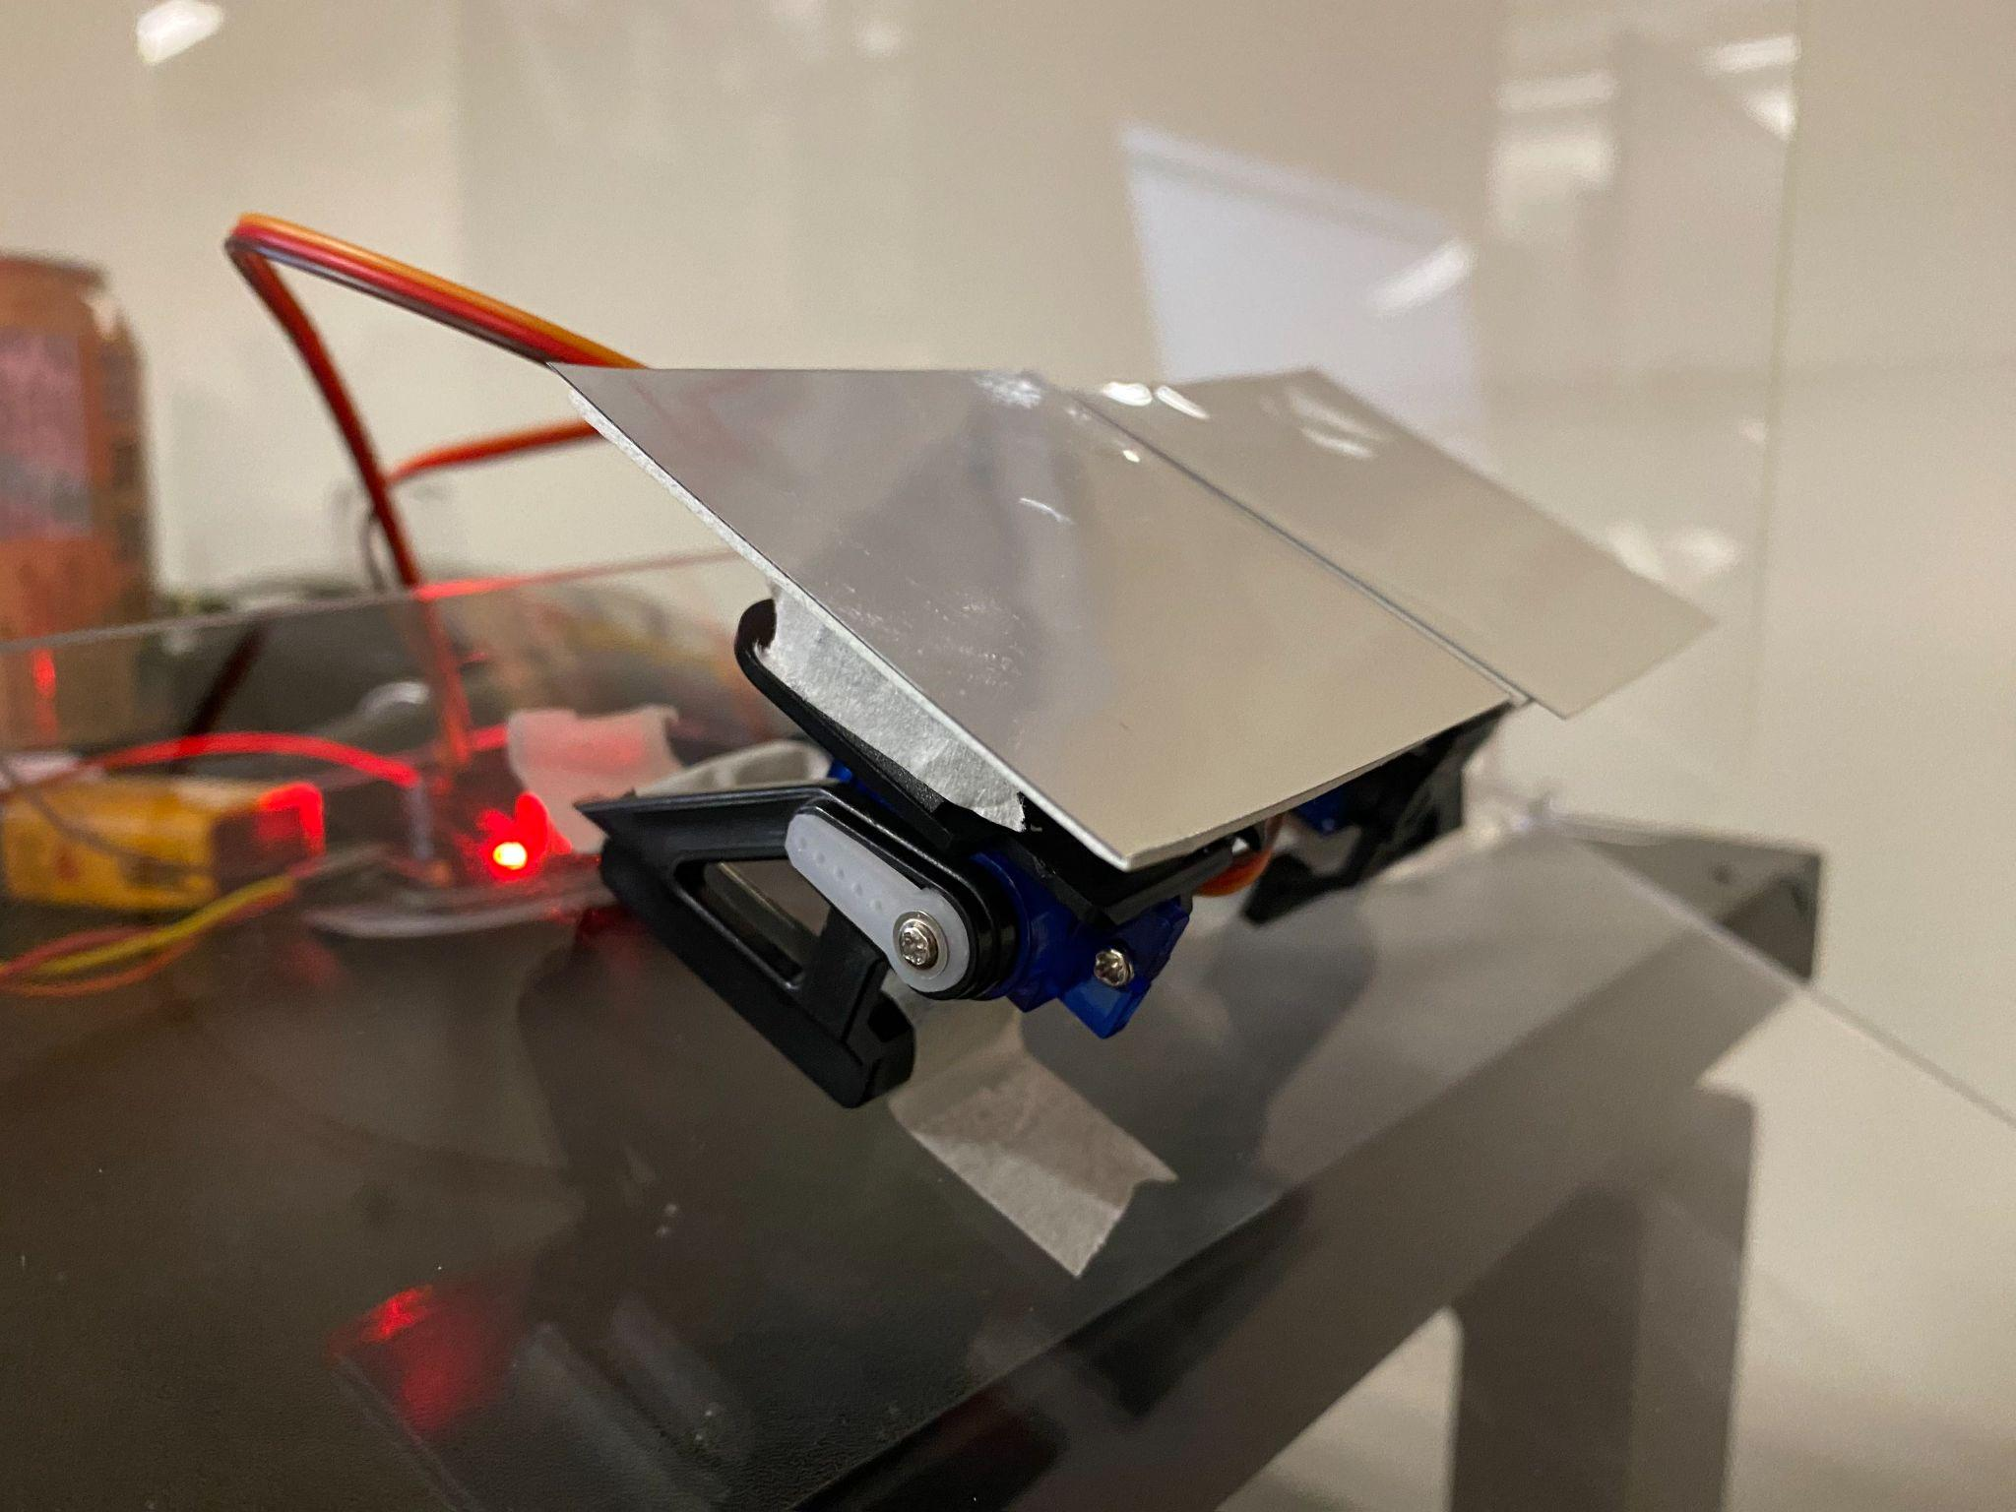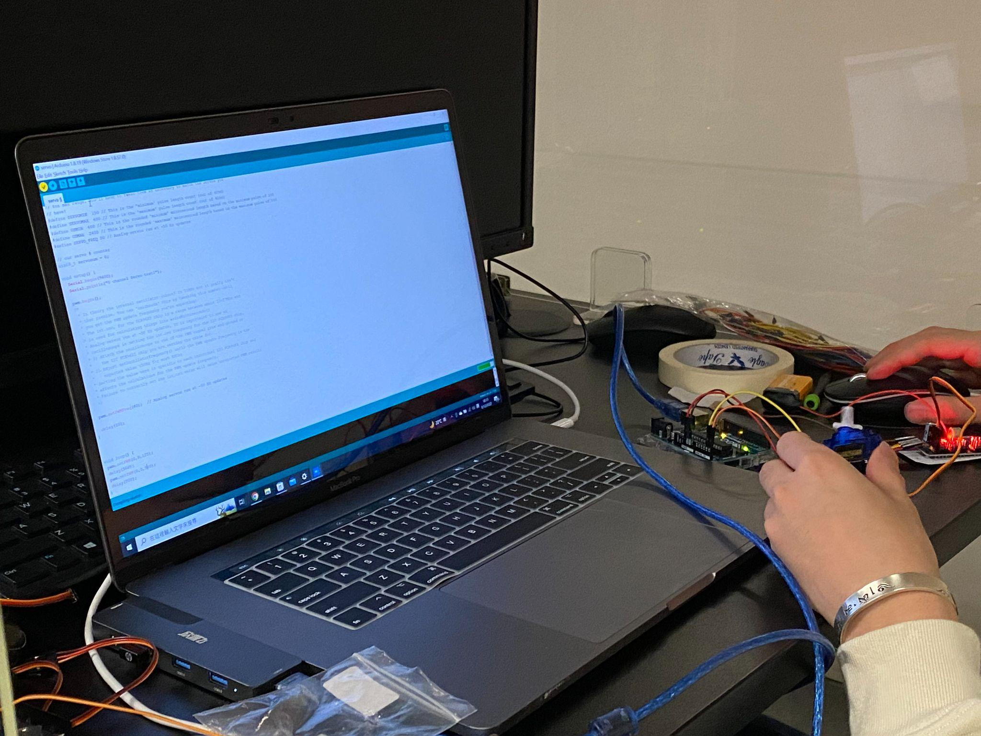

We use 3D print to make the arm and combine the moving mirror with motor. In order to stabilize the 3D print and stick all the things we use super glue.

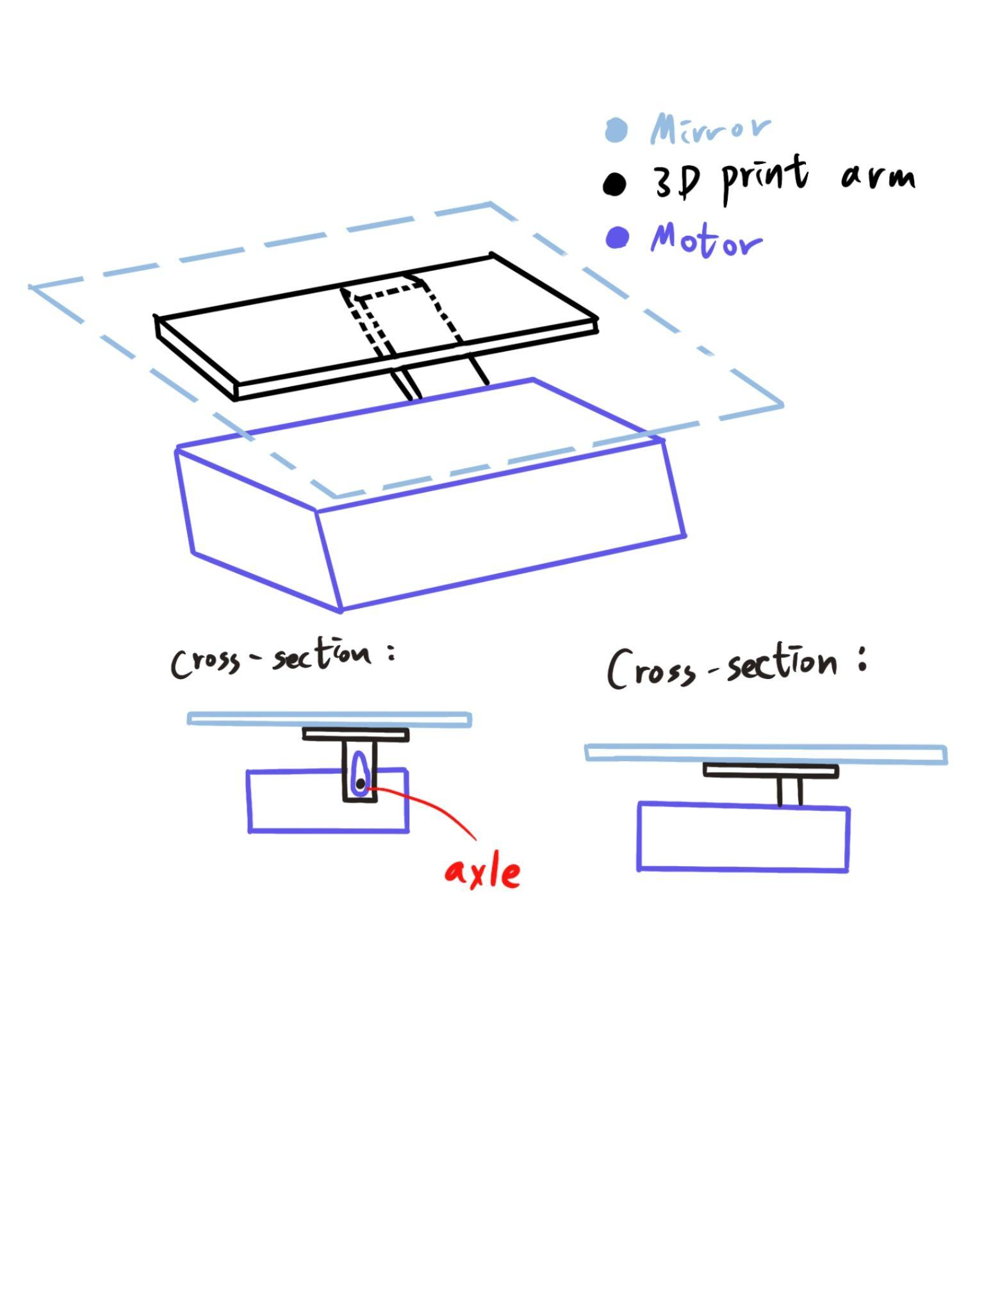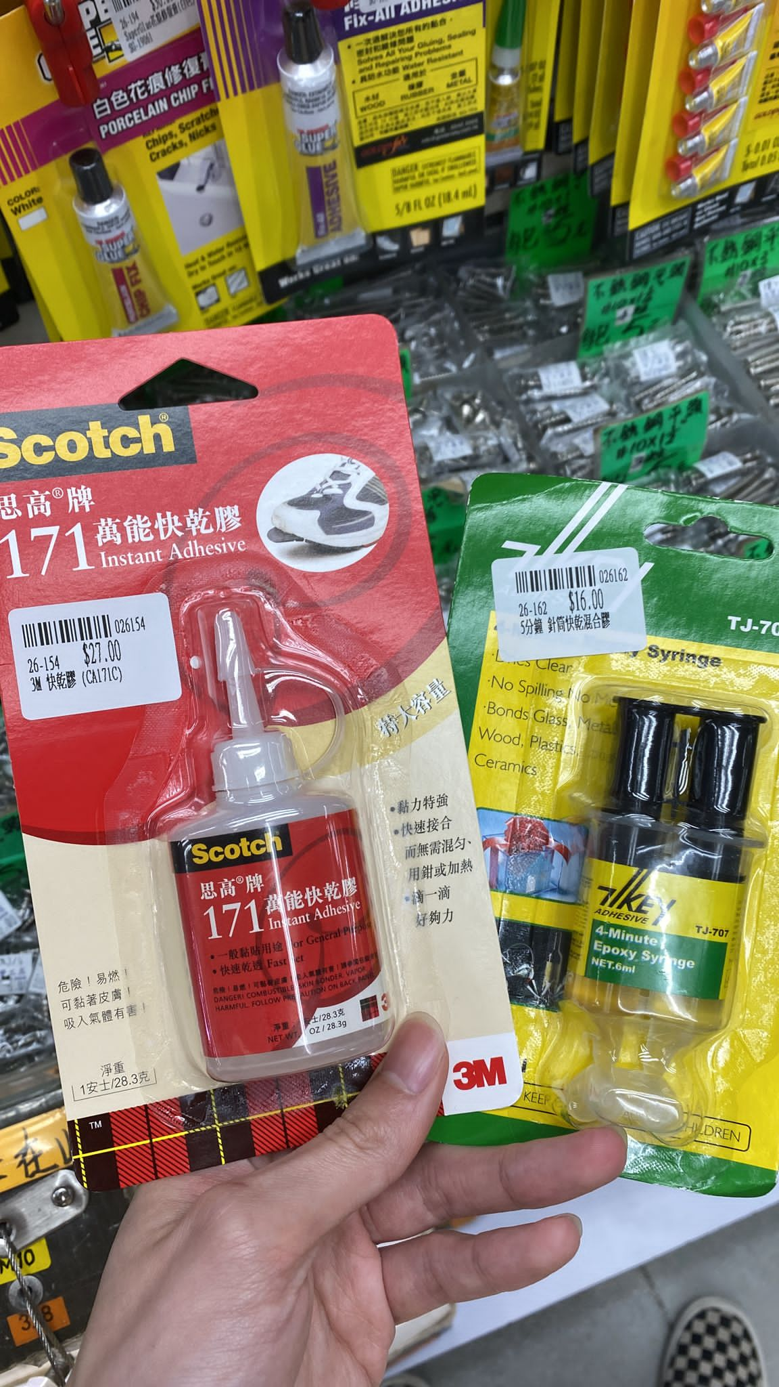

In the choice of wood materials: 9mm plywood is used for the wood board, and its quality and thickness are suitable. We used nails to stabilize the frame, and fixed the shape of the mirror with screws and tape. Woods are cut to calculated size and sent directly to cmc, then we build those frame by ourselves in wood workshop.

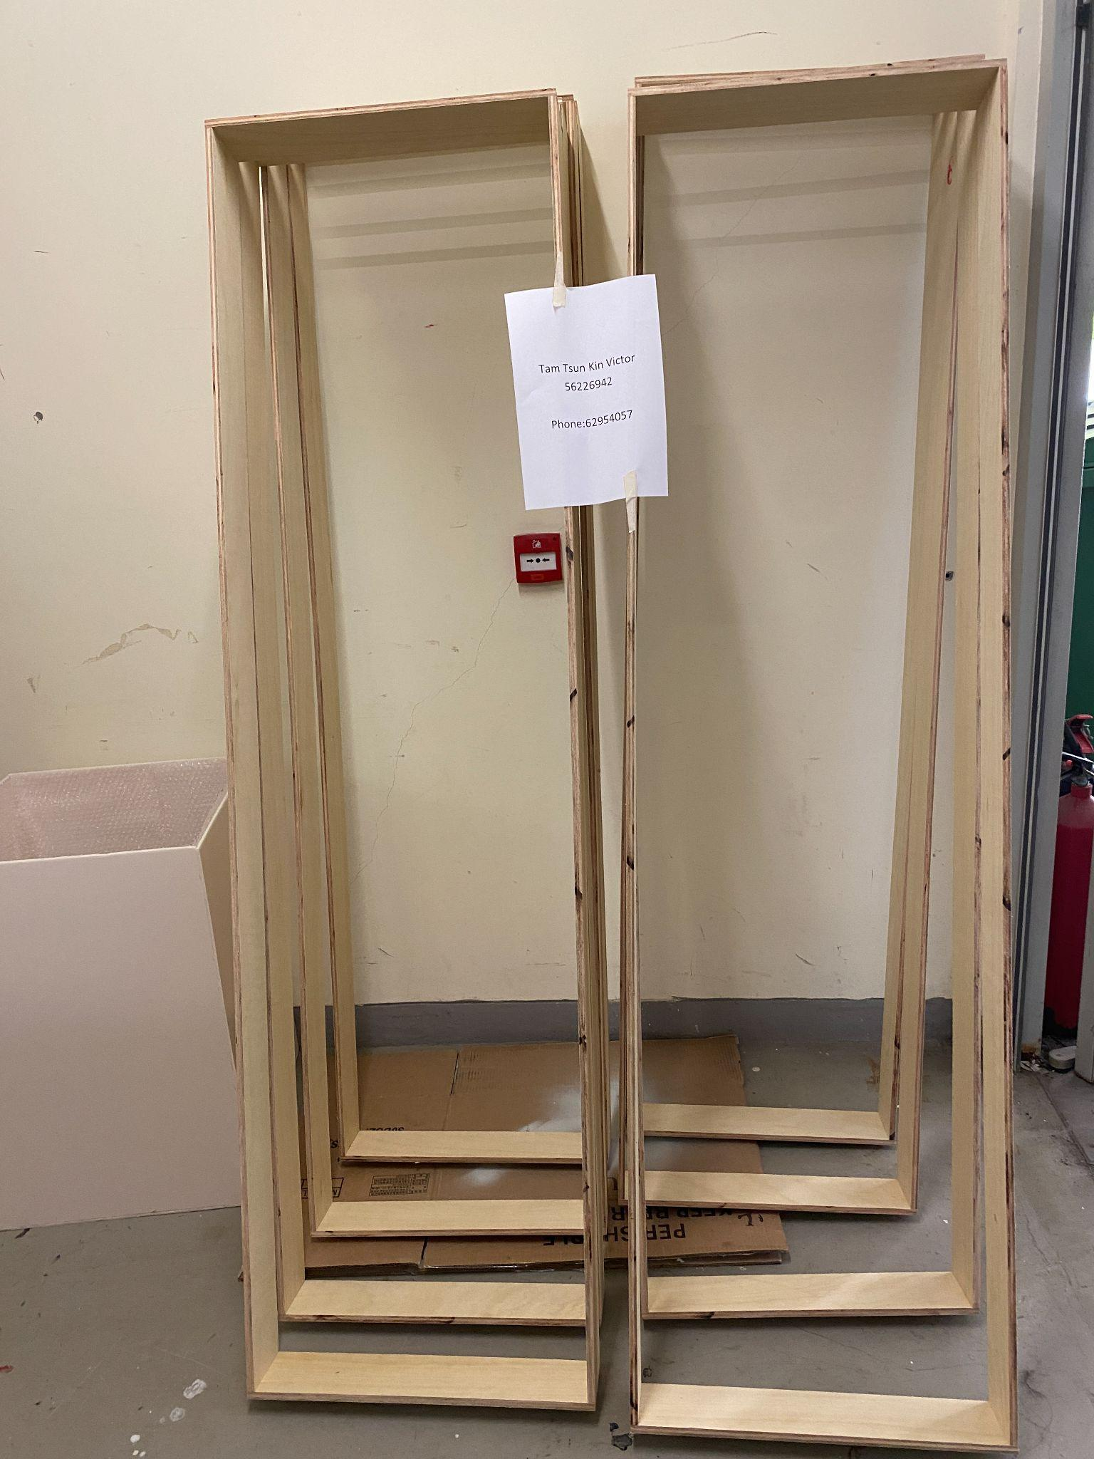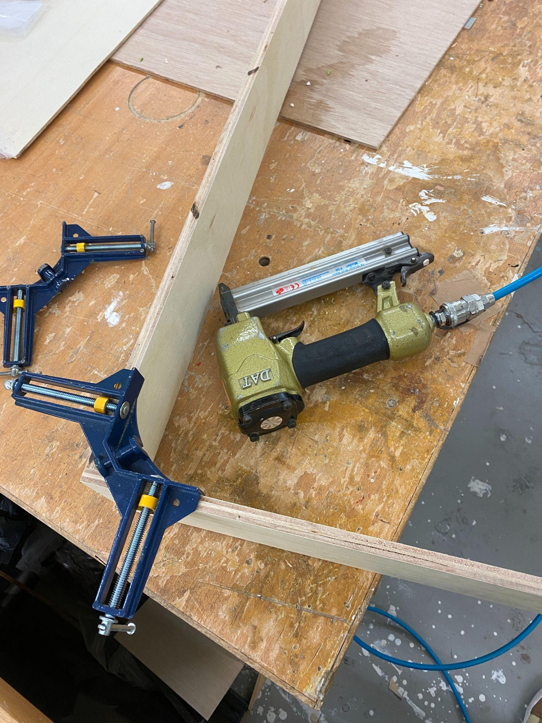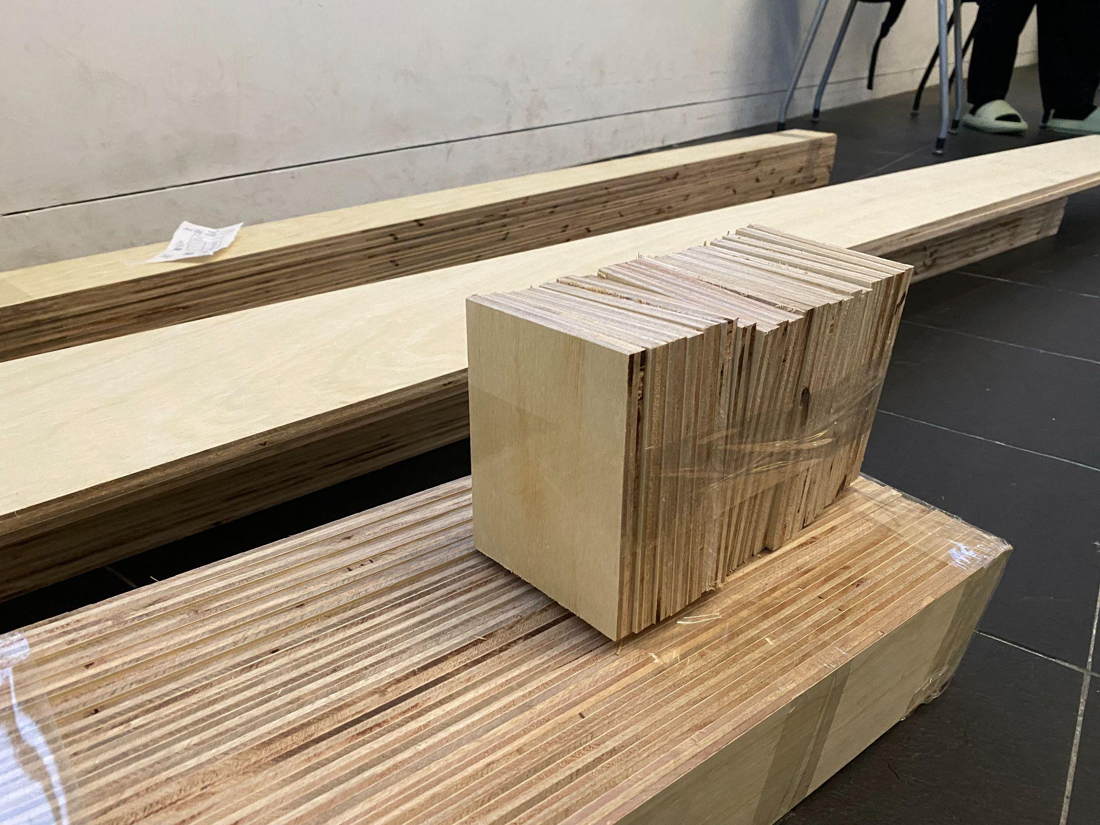

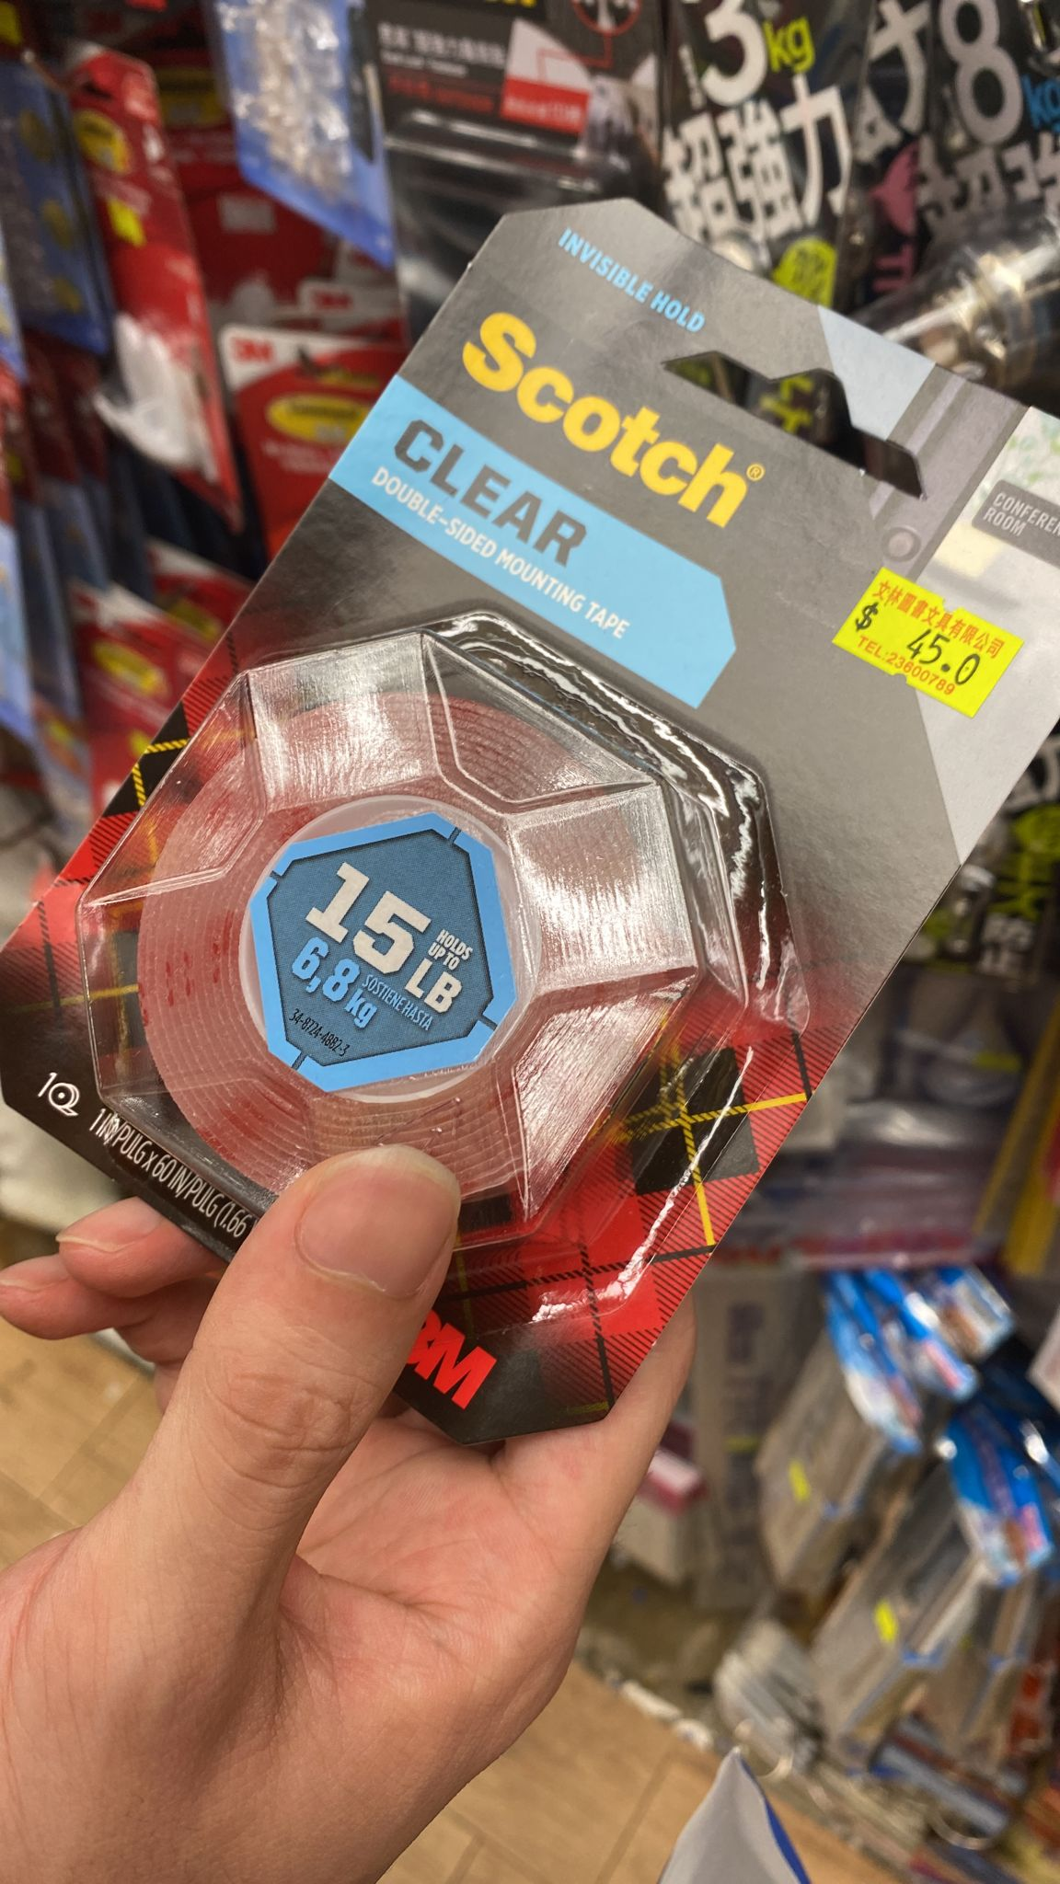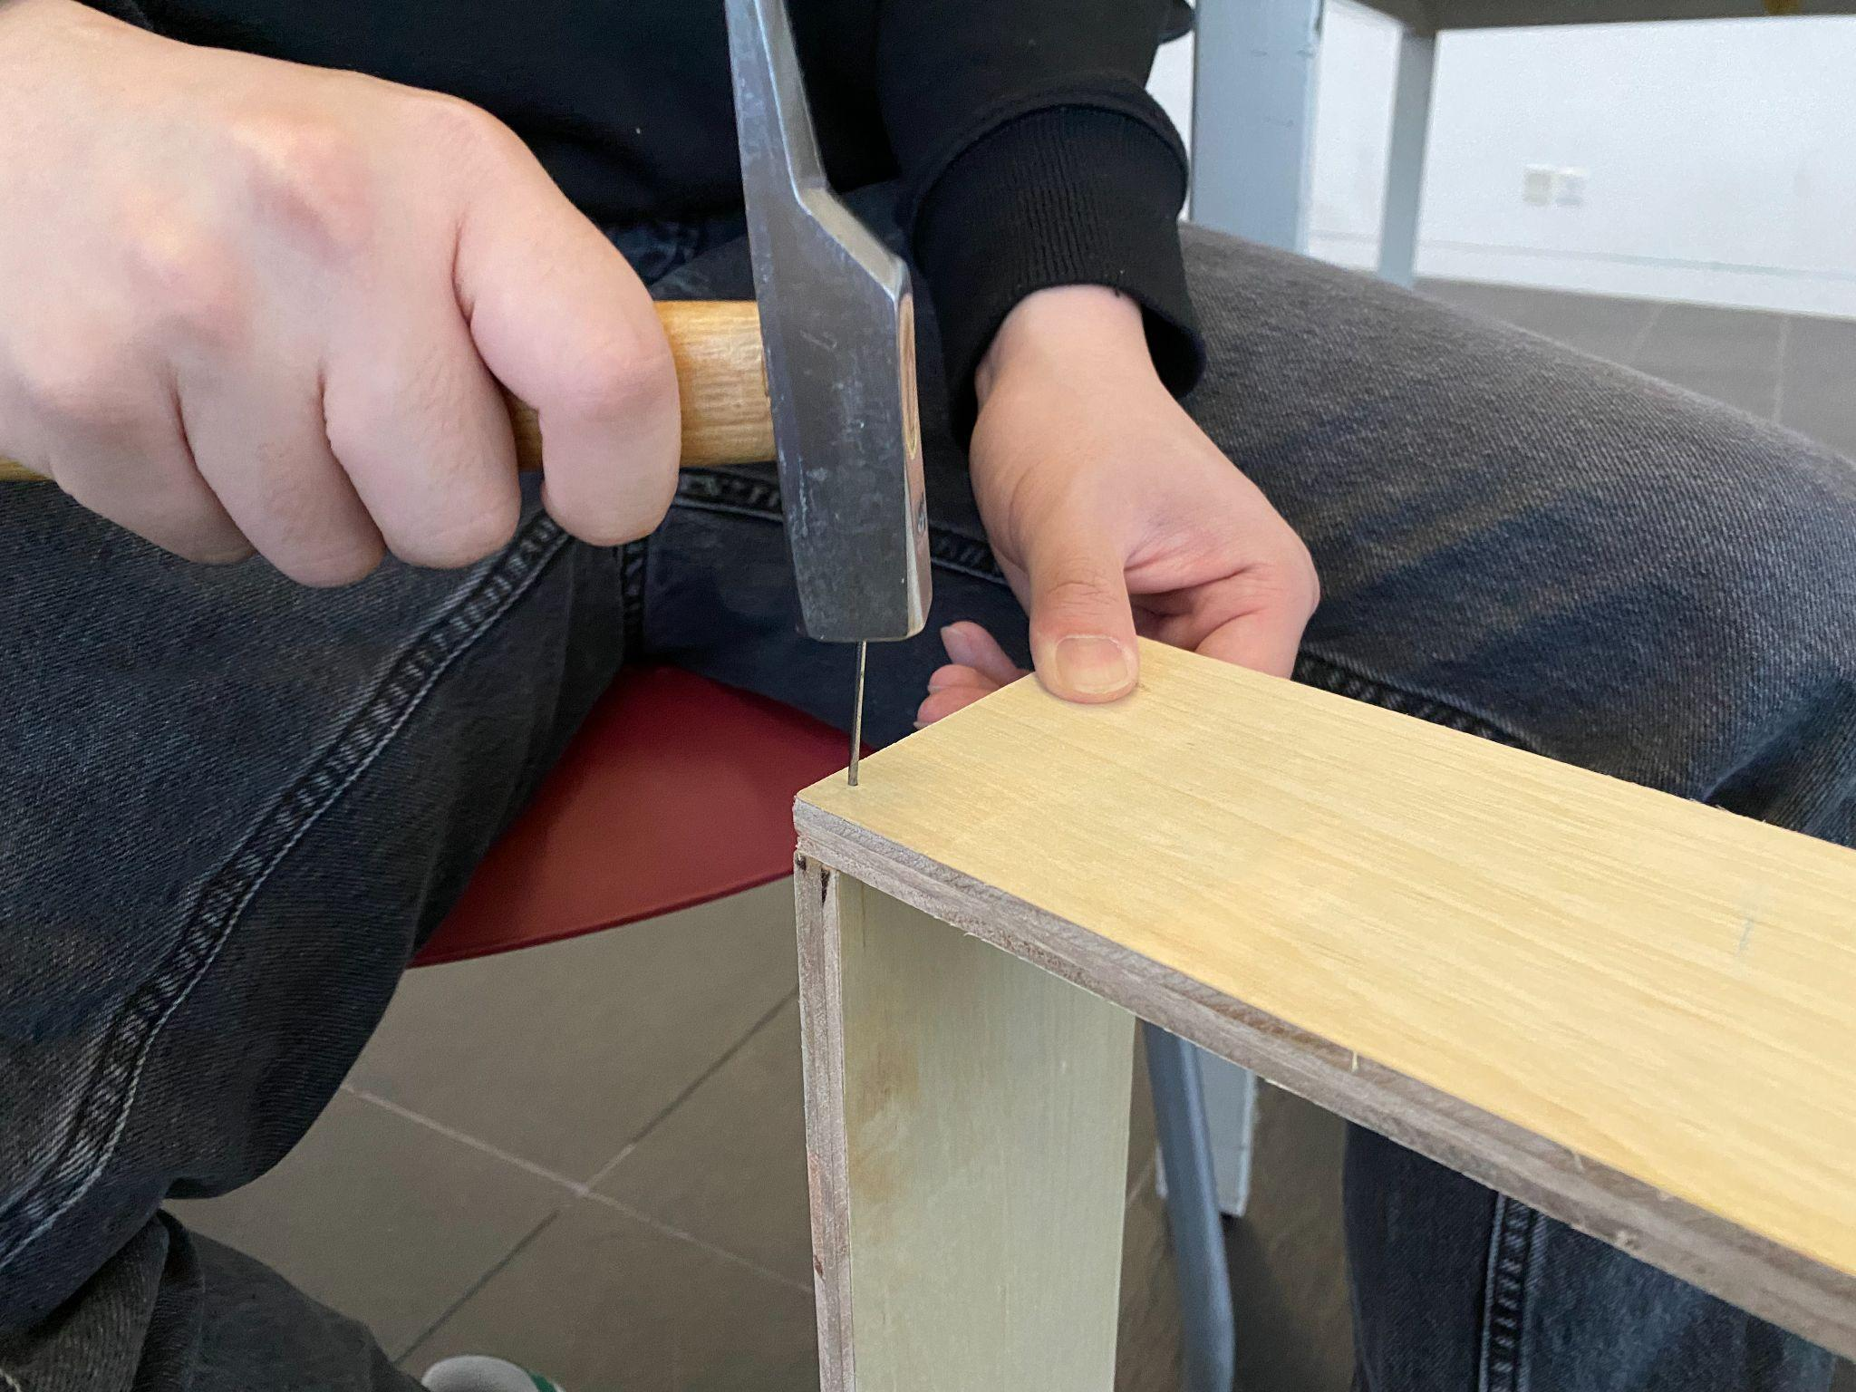

In the selection of mirror materials, we used paper mirrors, which are relatively cheap and easy to bend. It can be used as materials for different types of mirrors. But also used acrylic mirror, its clarity is higher. Moreover, they are light in weight and not easily broken, which is convenient for us to install and ensure the safety of the installation.

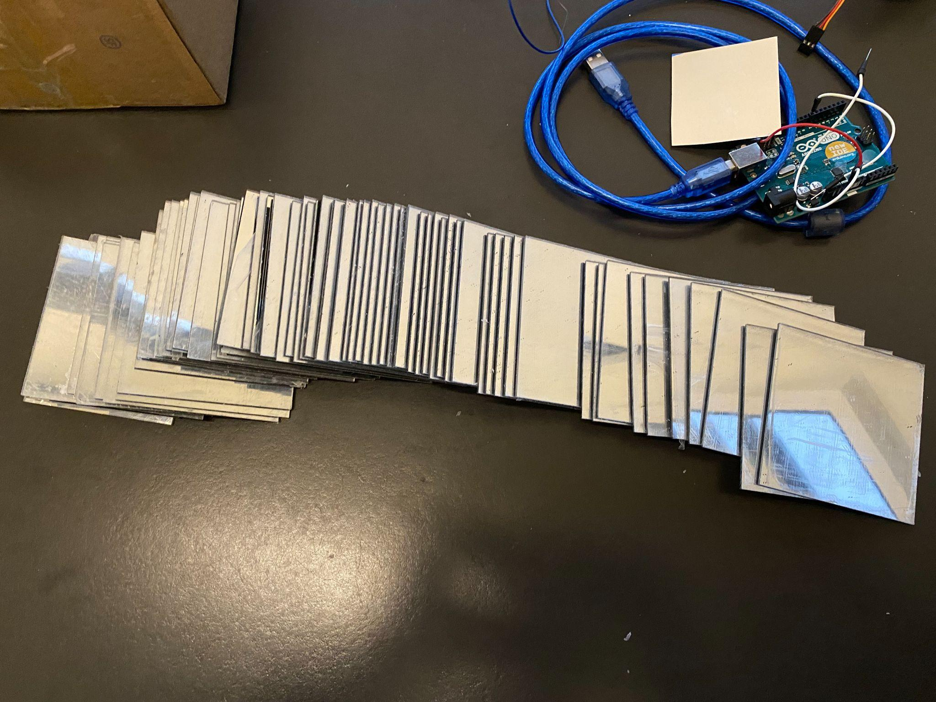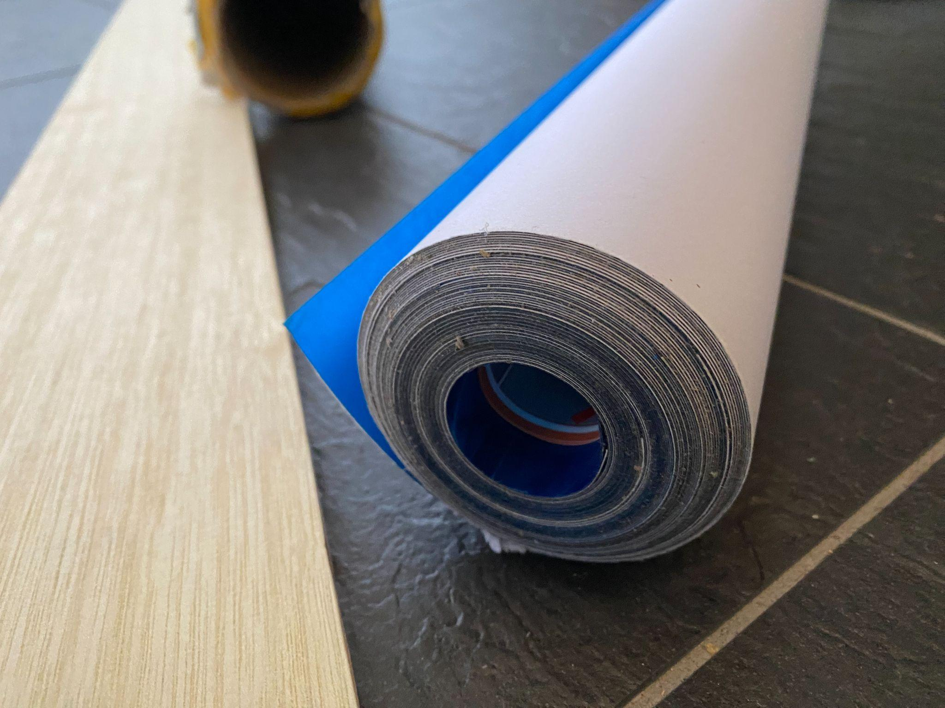

For the choice of paint, we used black Dulux waterborne enamel (eggshell).

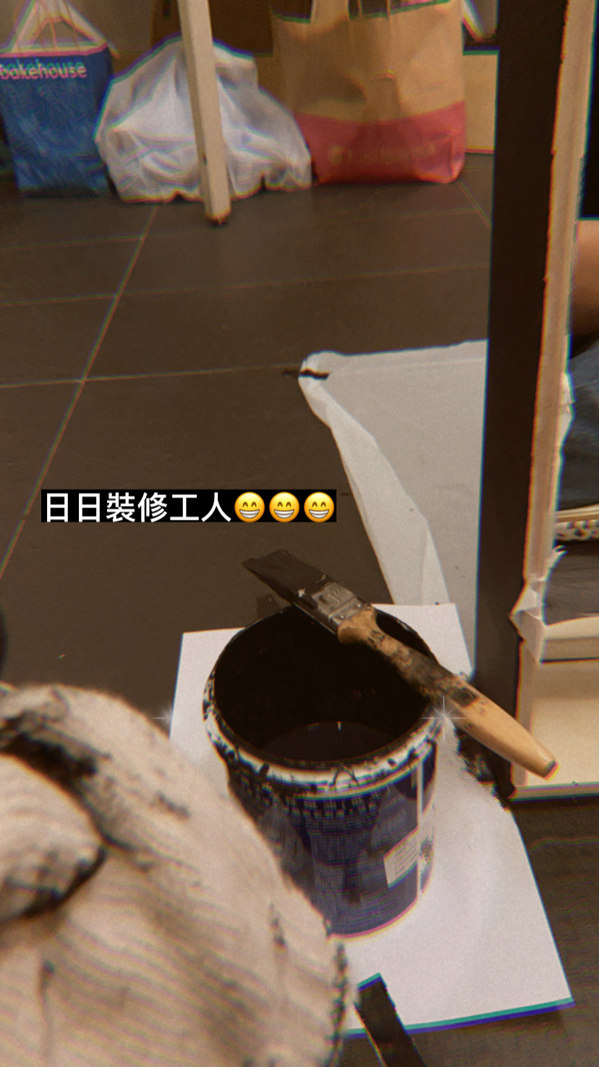

# 

# **Implementation and evaluation**

In terms of implementation, we successfully use the open space on the ninth floor of cmc which can provide enough space for the works. The overall setting uses the concept of Stonehenge, where the electronic devices are surrounded by sitting mirrors, and the visitor is surrounded by installations in our created space, so that they can move freely in the planned space.

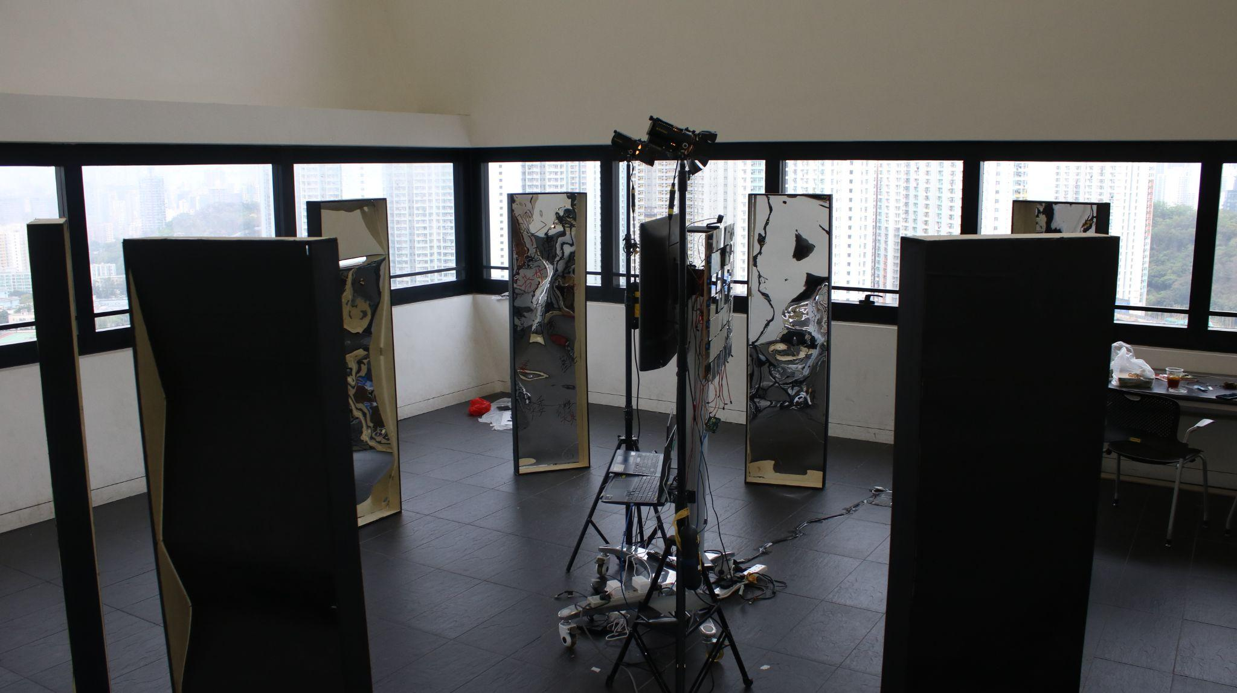

Firstly, the entrance is settled on the design path and other possible paths are narrowed to guide the visitor to enter from the predetermined entrance. Then, about the design of the mirror, a black frame was used instead of the color of the wood, so that the appearance is integrated with the black floor and contrasted with the white wall. It makes the overall appearance more comfortable and beautiful. These mirror are settled in special order, the order can bring different surprise without continous simple feelings. Different designs are made on the surface of the mirror, which are mainly divided into three categories:

1. Funhouse mirror, the image will be distorted, and the visitor will see their bodies being pulled, split, and merged strangely.

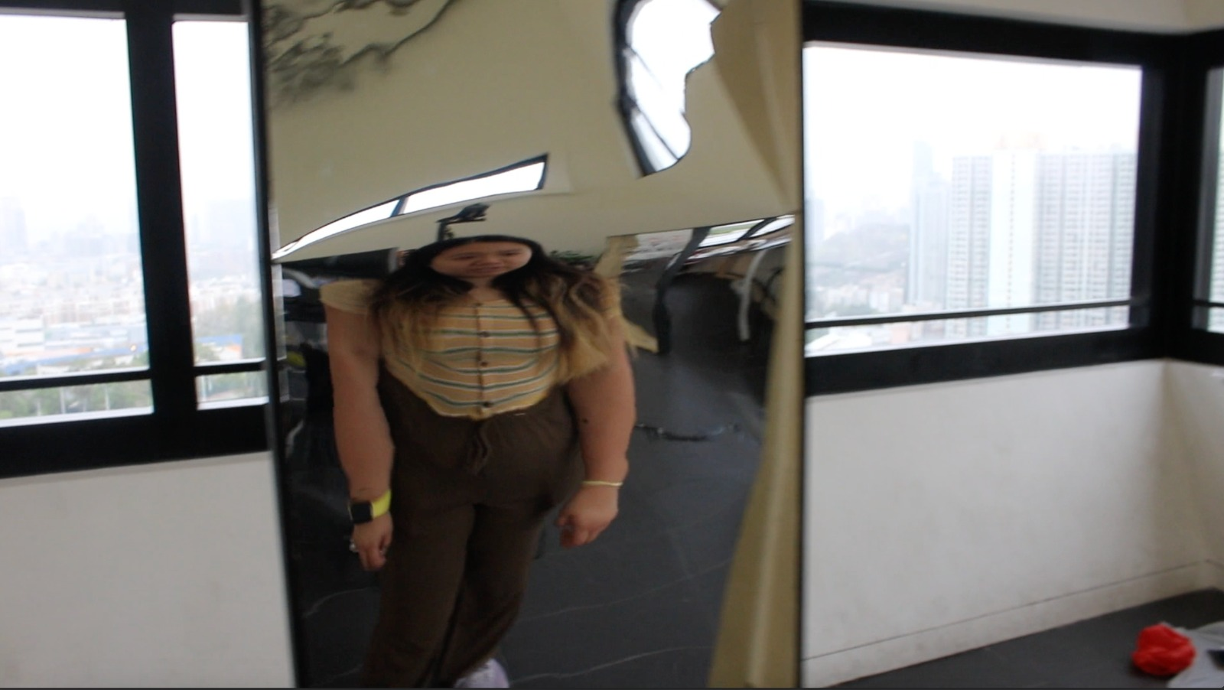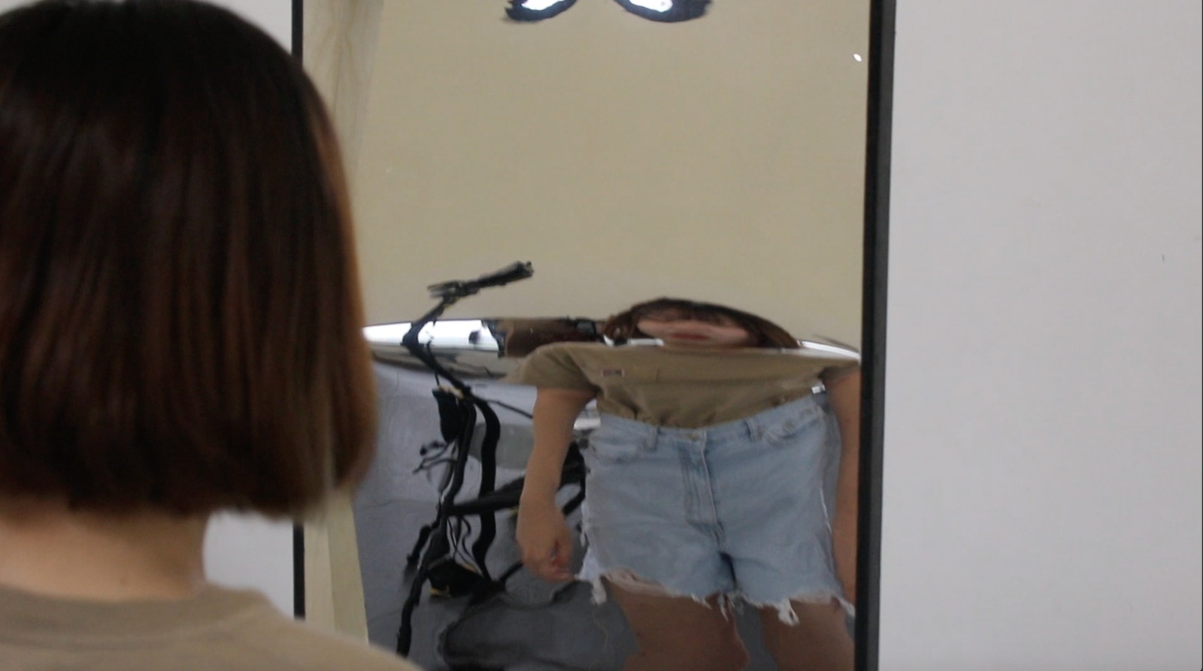

2. Broken mirrors, there will be different cracks on the mirror surface, including scratches and diffusion cracks formed by hitting. This will bring different visual effects and emotional associations to the visitor.

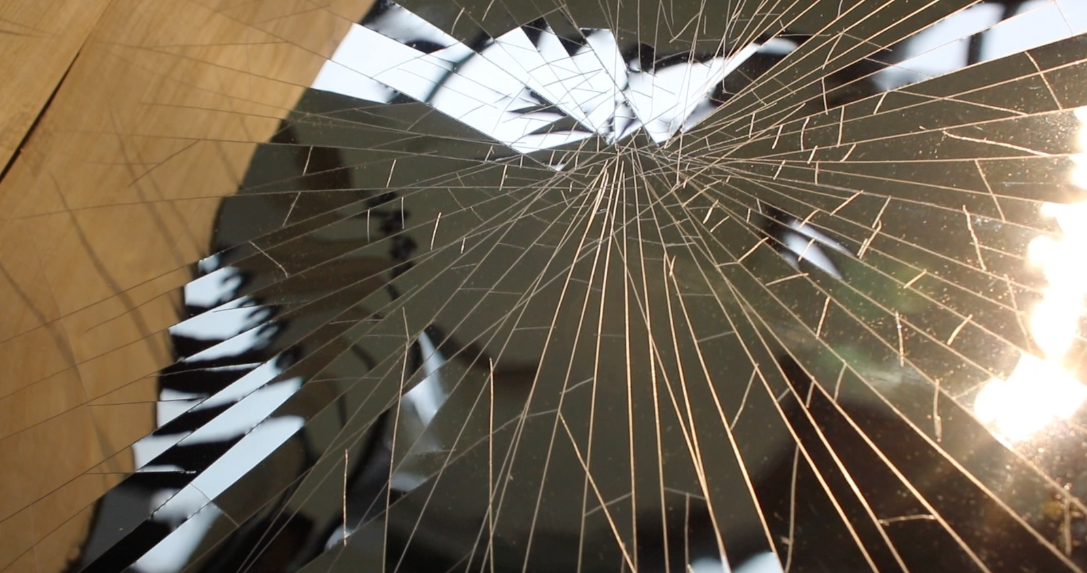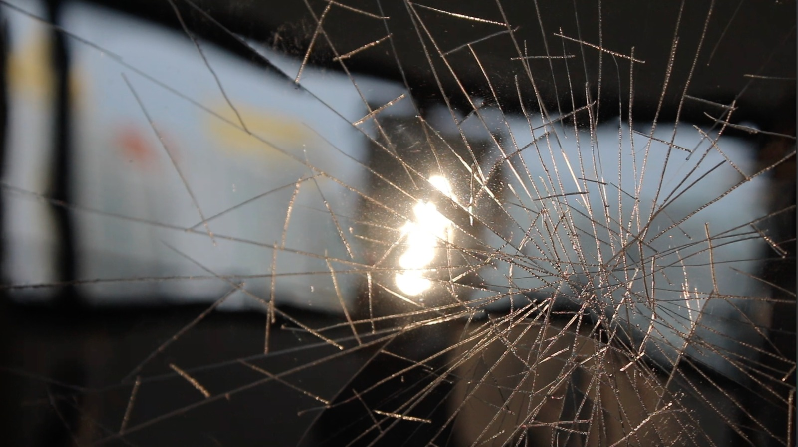

3. The graffitied mirror, there are different words and sentences written on the mirror surface. The words and sentences come from the labels, dialogues, etc. that you will encounter in daily life. Most of these statements are derogatory and offensive and the visitor will have stronger feelings and associations with them.

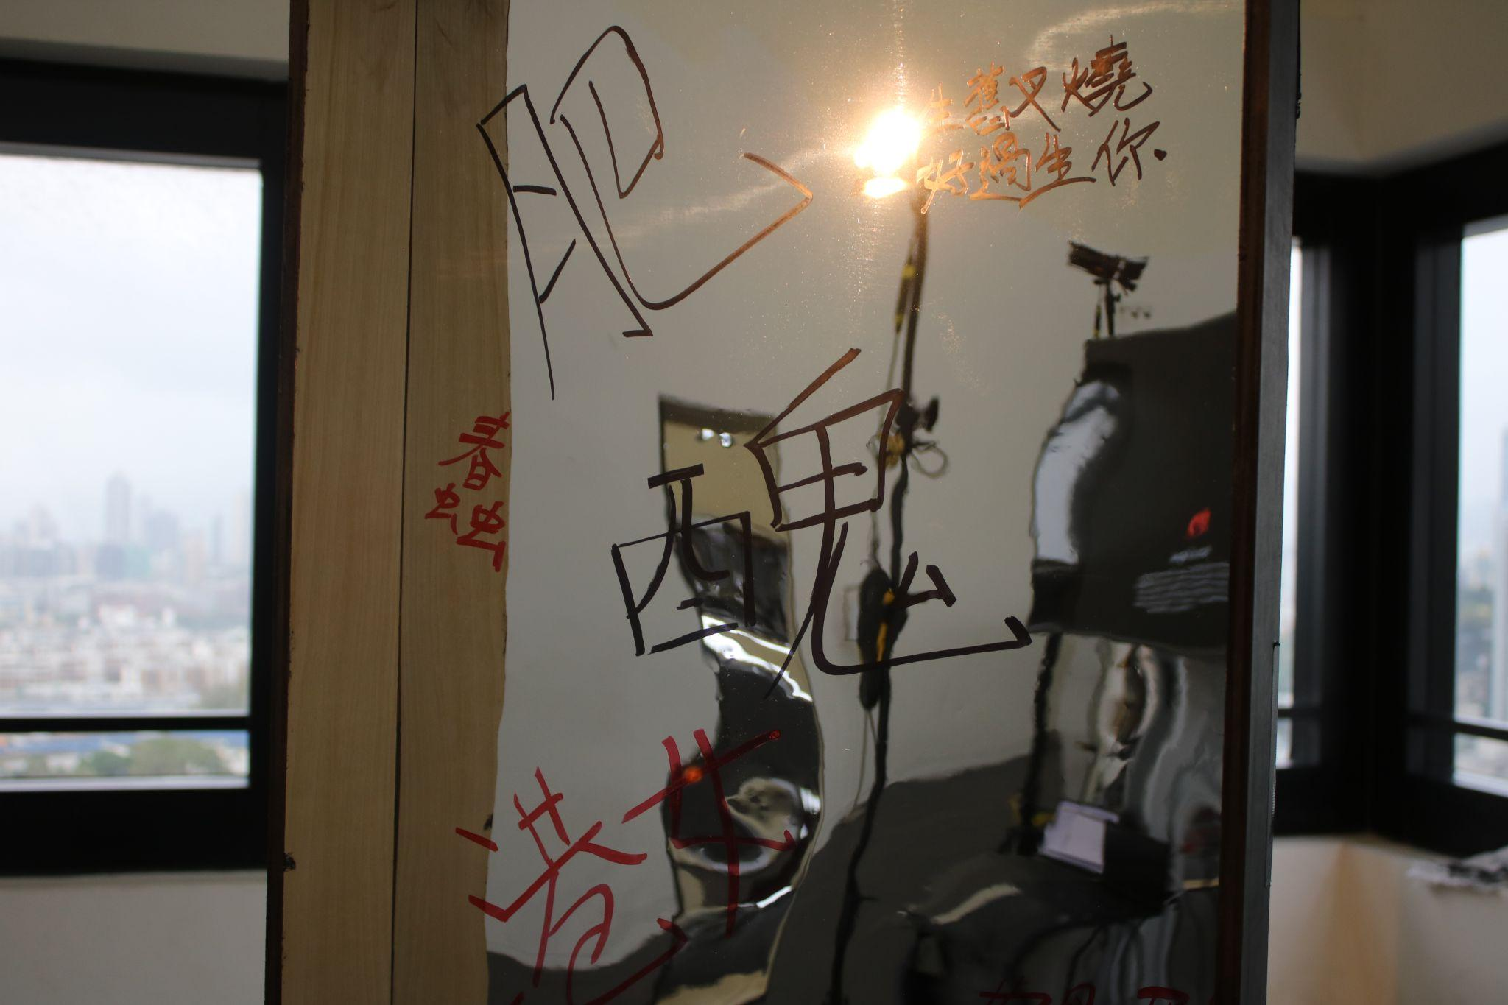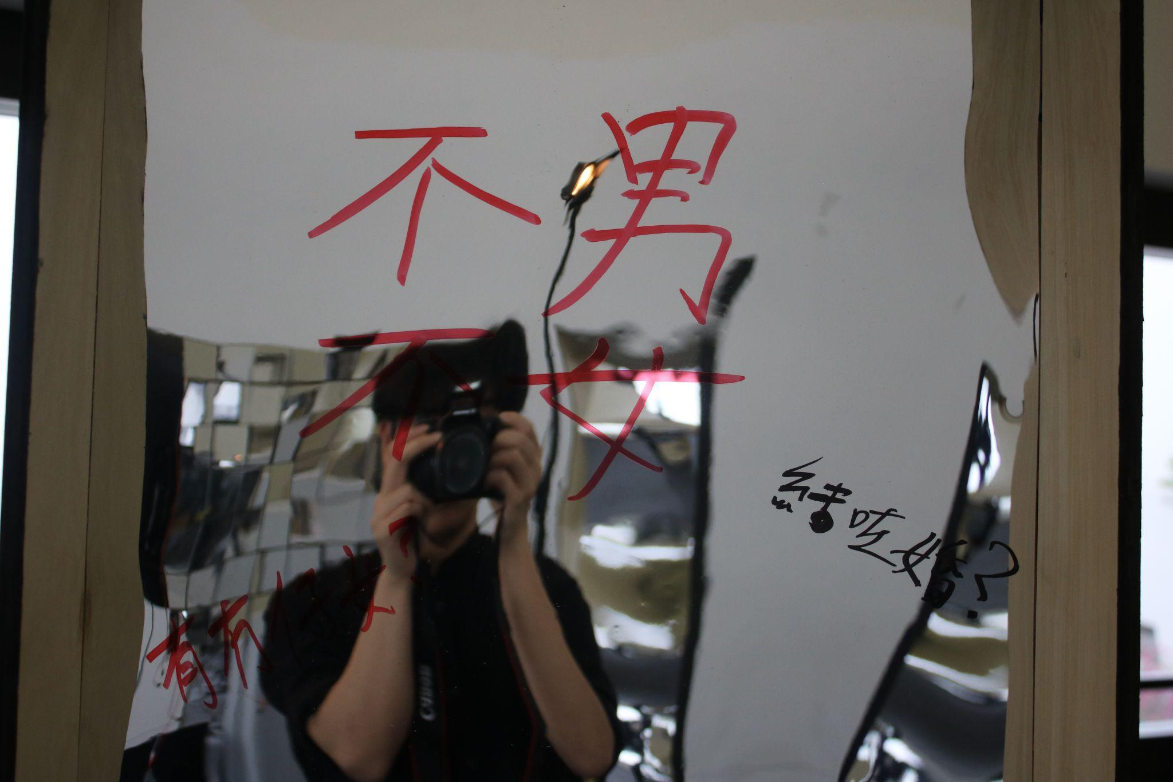

Then, after looking at those eight mirrors, there are two more installations that are concentrated in the middle. The first one, we combined seventy small mirrors into one large mirror and hung it on a large TV stand. When the camera senses the face, it will start to track the face and push the mirror to follow the face. When the visitor faces the mirror and move, the small mirrors will move at the same time. These mirrors are installed on the installation with the clearest and most flat appearance without any decoration or post-modification. Through the small mirror, the visitor can see the "real" self from multiple aspects and angles.

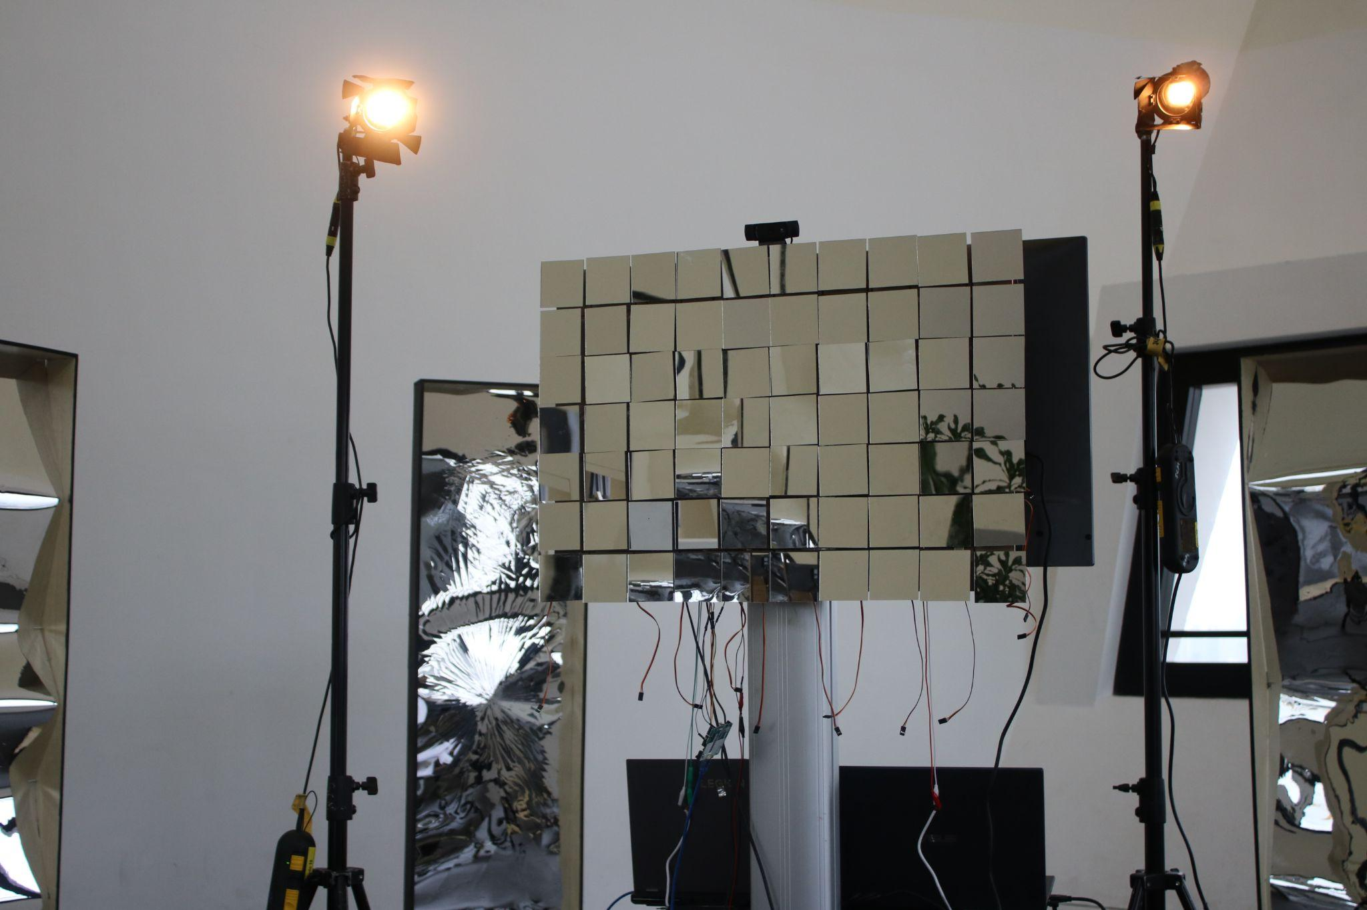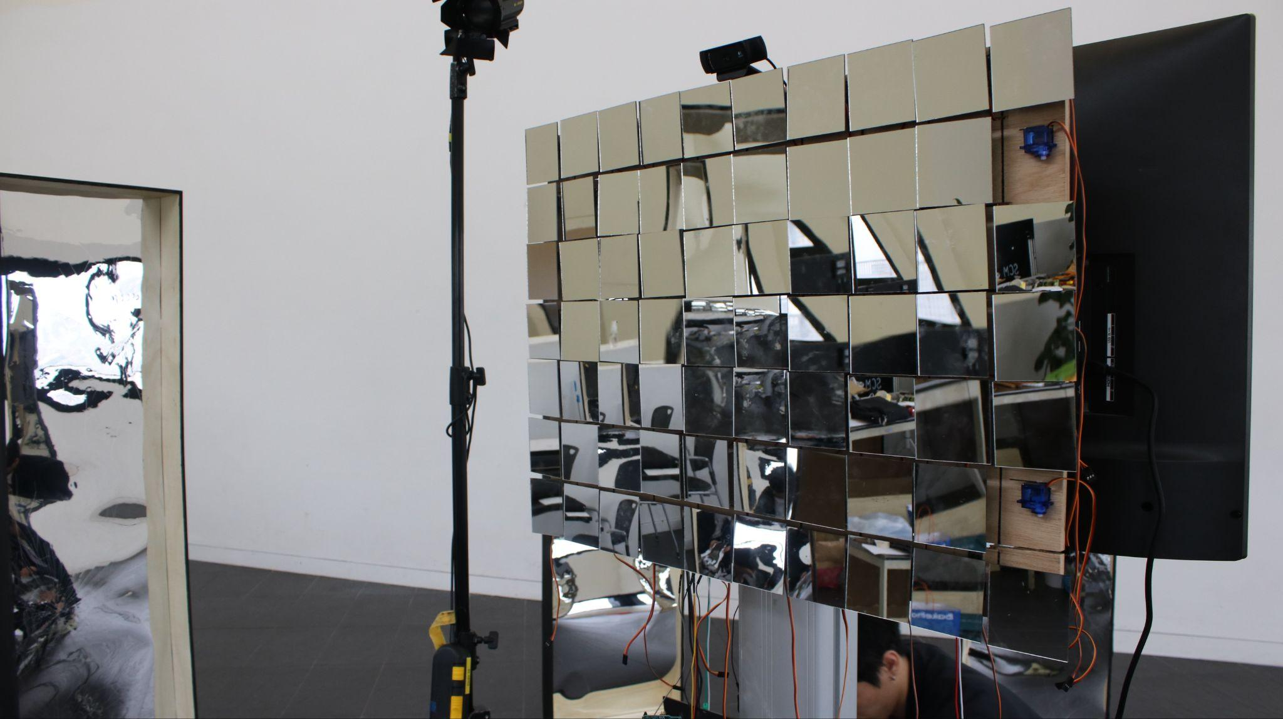

Finally, the TV is placed on the back as another device, which is similar in height and size to a large mirror. Through the camera, the visitor is divided into different parts and displayed on the TV on different nine grids. The audience can find out which grid is reflecting which one part of himself.

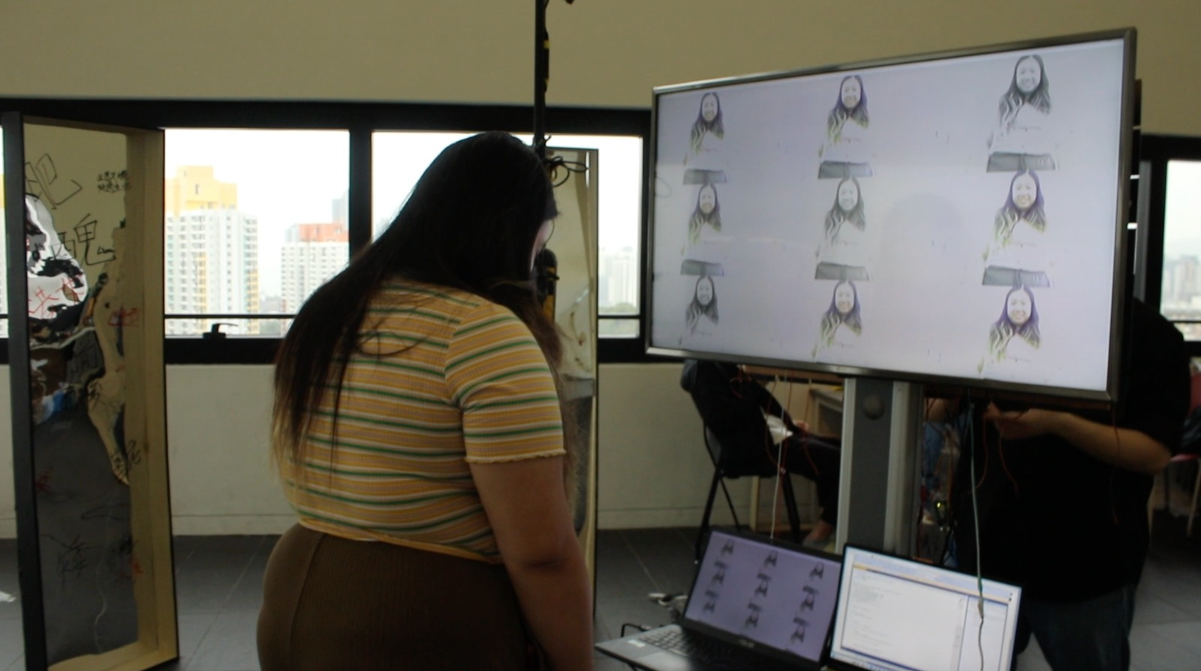

Through space planning and installation design, the work brings perspective effects to the visitor from different aspects. The visitor will pay attention to each reflected image and think about the meaning it expresses and will be guided by the work to induce different emotions and associations.

Visitors can feel amazed by the transformation of their own appearance from the eight peripheral mirrors, and none of the eight mirrors is unprocessed. They all represent different selves, but these selves are defined by others, we get thousands of selves with different images through the eyes of others. Through these eight mirrors, visitors see a different "I". They will be provoked to think about the effects and words they see, whether the sentences are applicable to their own situation, immersed in trying different angles to see different visual effects. The next part of installation is to give them a completely subverted self-image. Compared with different visual effects, the original mirror shows the most intuitive self. Seventy mirrors move with the visitor not only to surprise, but also to provide multi-angle reflections. This means that when participants can see clear images from different angles No matter how they move, there will always be a piece of mirror facing the visitor. We can find seventy "I" in it, but they are all real "I" and the same "I". Including the nine-frame displayed on the TV which is the process of the participants finding themselves. Visitors can clearly recognize themselves through these two mirrors.

Therefore, this work can achieve the process of self-reflection: lost, searched, self-reflectioon.

**Discussion and analyze/Data collection**

In our prototype, we successfully control 9 servos moving together to a certain degree by giving them a particular pulse value as mentioned.However,during the process of constructing the final mirror , we encountered different types of difficulties and some managed to refine and resolve it.

To construct the final mirror installation, instead of giving all servos a particular value in the arduino coding, we need a way to get the face information of the visitor standing in front of the mirror and transmit it to the arduino. In order to achieve it, we have looked into different kinds of body or face detection technology and figured out that markerless mocap technology is the most suitable one after considering methodology and cost.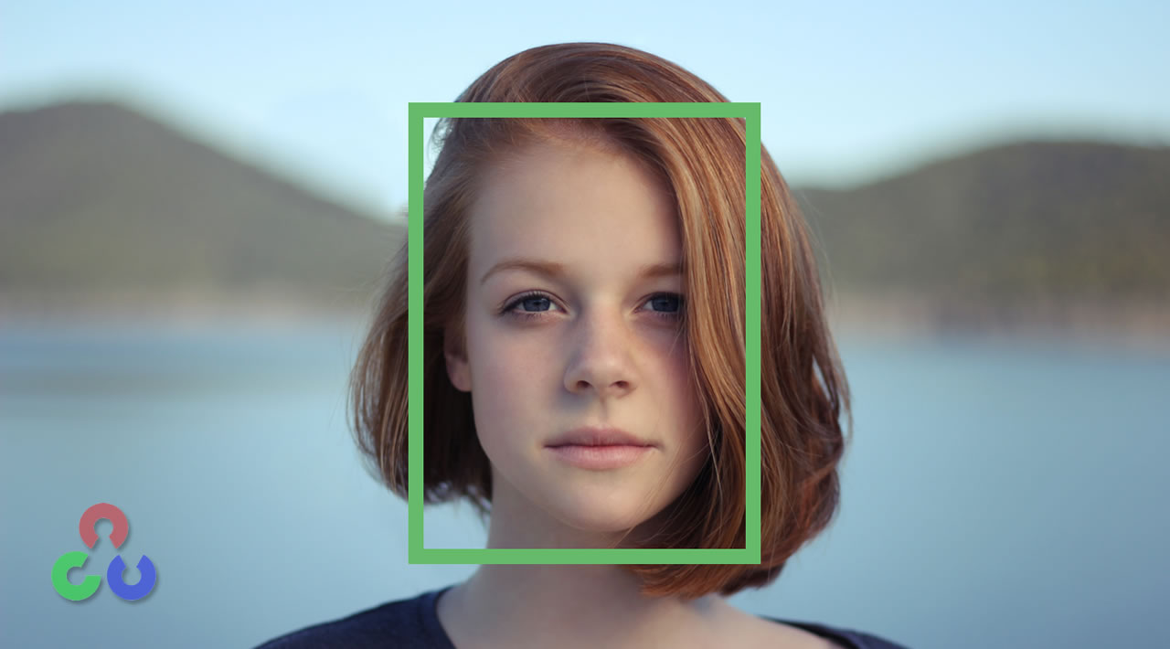.

The one we used is the face detection of cvzone in the opencv library. It is a rgb video based markerless detection technology using the concept of Haar Feature-based Cascade of Classifiers which indicate that if an image passes all stages of the classifiers, it will be recognised as a face ,otherwise it would not.We only take the x-coordinate of the bounding boxes built in in the library to represent the face coordinate of visitor as it is too expensive to also built servos controlling y axis.

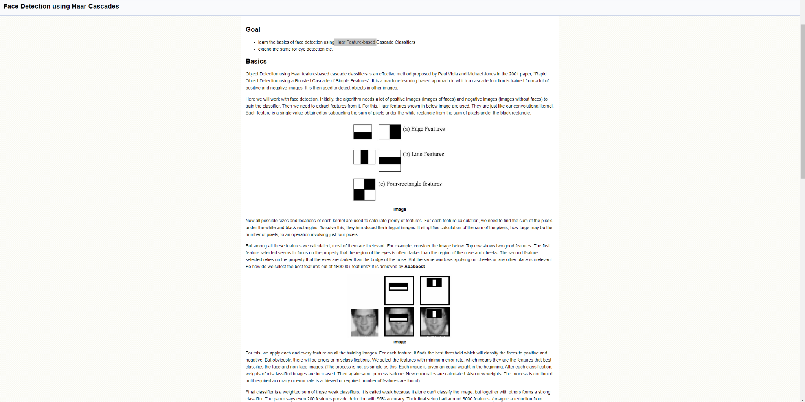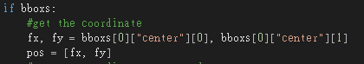

In order to implement the face detection into the arduino, an additional platform is needed as the arduino can not directly access the opencv library. Therefore, we decided to implement python as the platform to access face detection and meanwhile control all the servos in the arduino.

Firstly, we found out that the pyfirmata library can be used to achieve such an objective because it basically builds a signal bridge between python and arduino using I2C communication so that we can directly write information on the arduino board via python. Unfortunately, the pyfirmata library only supports us to directly digital write on the arduino board pins 1-7 which means we have to use the whole board to control only 7-8 servos. This is not practical as we need to control up to 70 servos at the same time. As mentioned previously, we are going to use the pca9685 16-channel servo driver as multiple selfs can be chained up so that only 1 arduino board is needed. However, pyfirmata library does not support controlling the pca9685 via python so we need to find another way to solve it.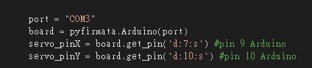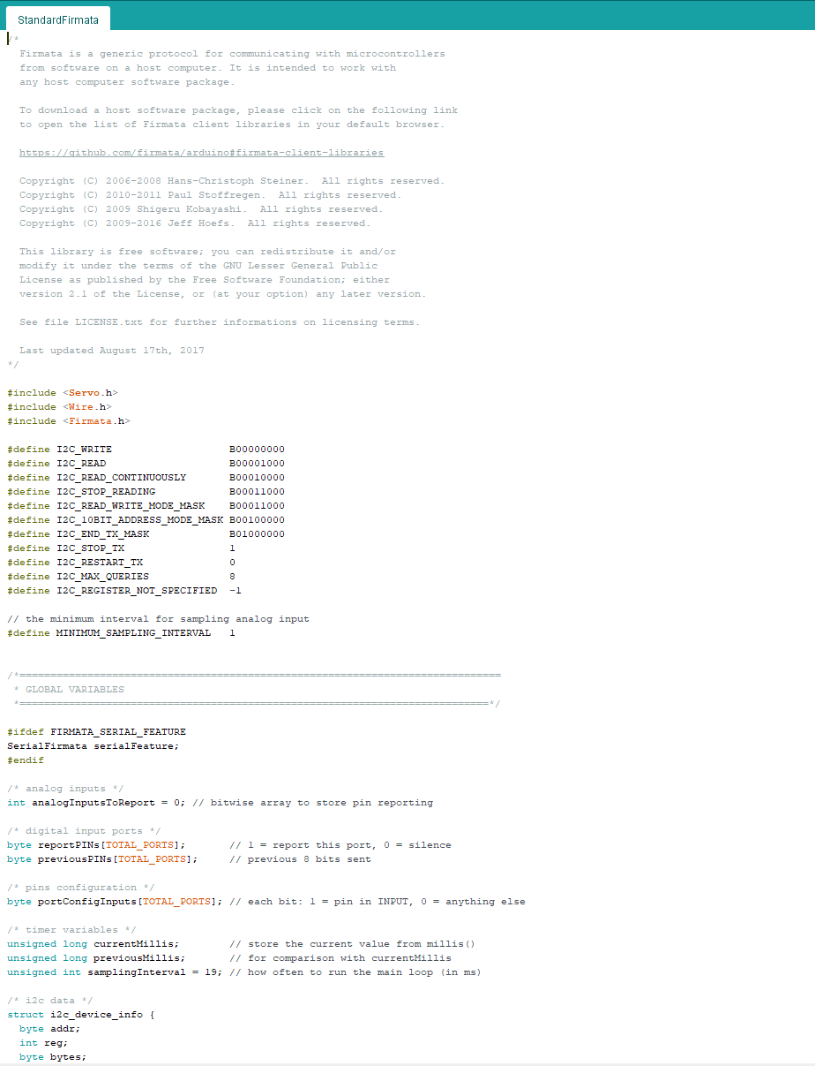

After doing tons of researches, we found out there is no way to control the pca9685 connected to arduino boards by python.Therefore instead of controlling the pca9685 on python, we decided to send the information of faced detected in python opencv to arduino via building up a serial bus communication between them.We first set up the serial port communication on both sides with 9600 baud (bits per second data rate)

, then send it from python and read it from arduino at the same time.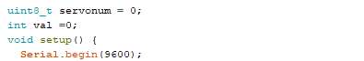

As we are trying to implement this method,we ran into errors that either python could not send out data correctly or arduino could not receive data correctly. To send out data from python via serial port using serial.write() function, we have to encode the data into string type first and send it .In the beginning, we tried to encode it using ASCII/UTF-8 format ,but it would not work at all,also as the x-coordinate data generated from the face detection is in float type ,we have to first change it into integer type before encoding as float type may use too much bits. Fortunately we solve these by using only the built-in .encode function in python.After that , we have to tackle the issue in arduino as well to eliminate the error, instead of directly use the Serial.read() function, we have to create a string variable and combines the Serial.readString() as well as .ToInt() functions to decode and store the data.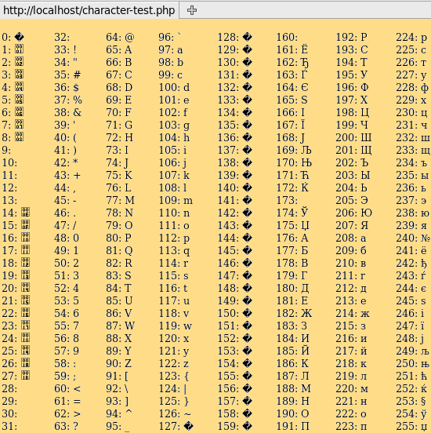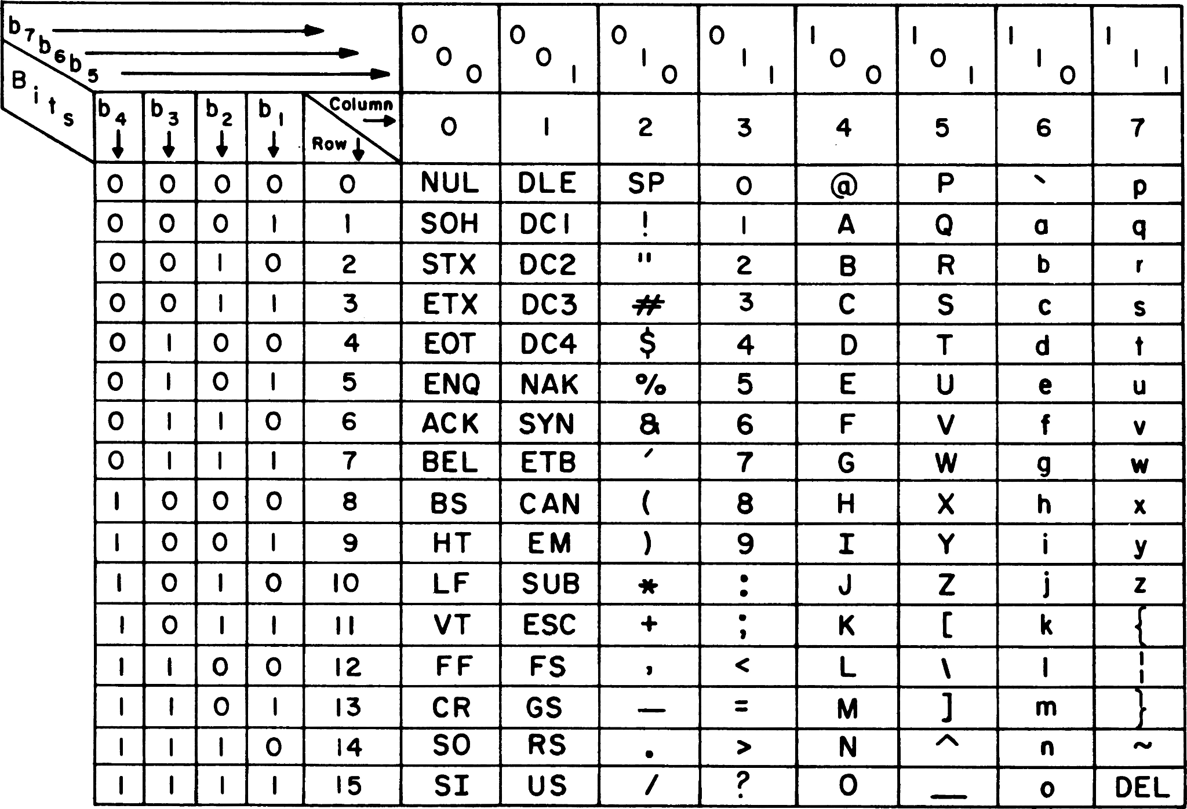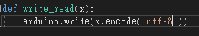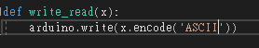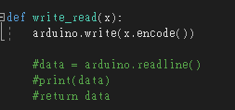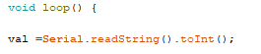

Although we resolved some errors in coding and software, we still face a lot of issues regarding hardware.

As mentioned, we were going to control up to 70 micro-servos at the same time. Instead of using the digital pins on the arduino, we used the pca9685 16-channels servo drivers to control all the servos and had to chain up 5 pca9685 as 1 can only control up to 16 servos .To achieve this, we need to manually solder them with electrical soldering iron, we found it very challenging because we are lack of experience doing it perfectly. As a result of imperfect soldering, the data and electricity connection between each board is weak and non-stable, which seriously affects the smoothness and accuracy of our final product.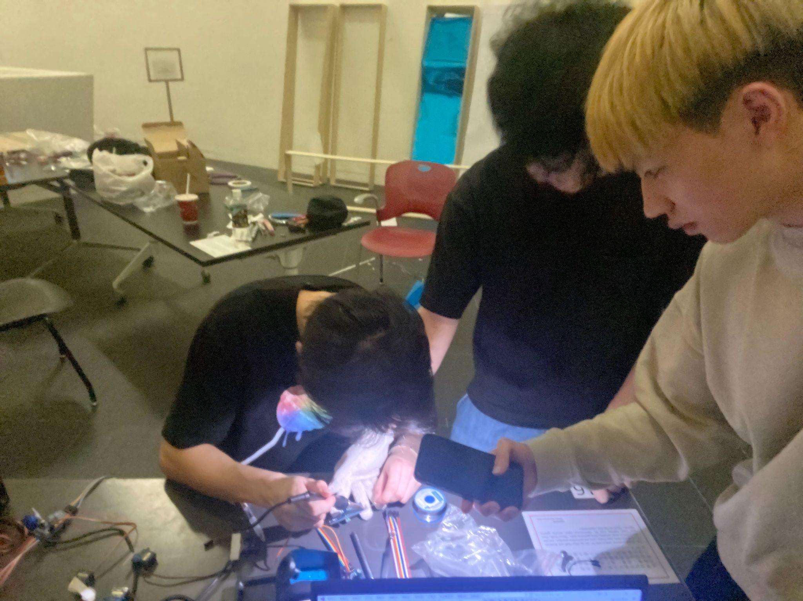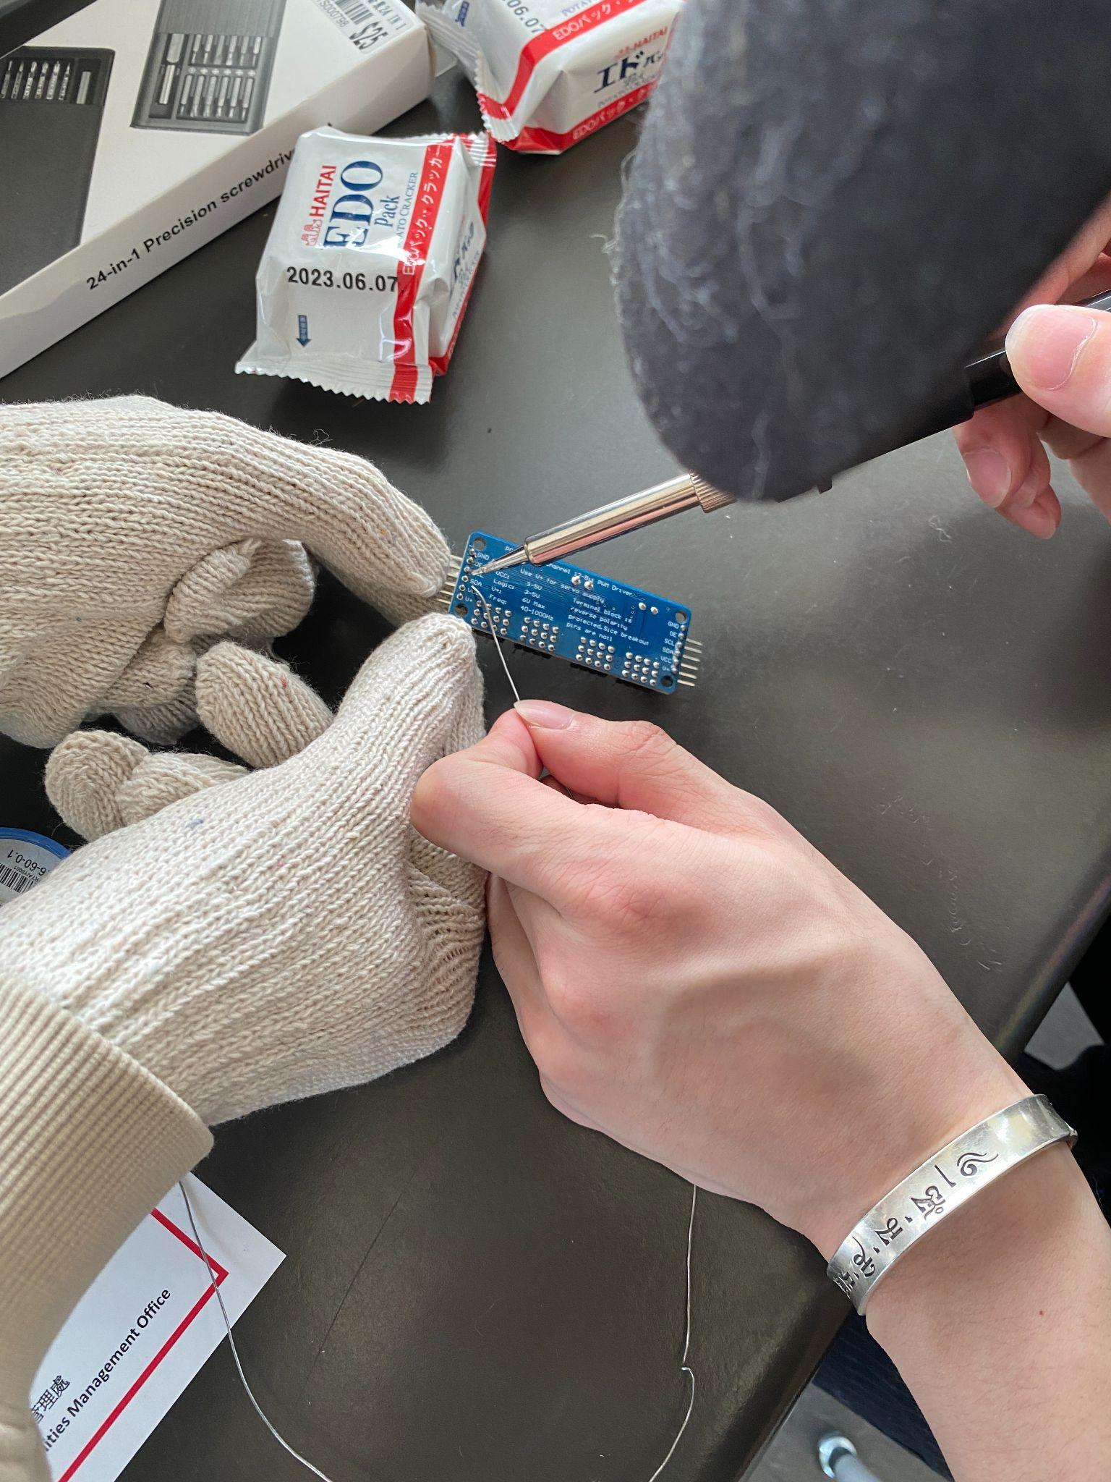

In addition, we found out that the camera and environment brightness also has an impact on our work. As mentioned, the face recognition technology and library is a markerless video based one, therefore it will be easily affected by the quality of the video. Typically, the face detection in cv2-opencv is in grayscale as it will convert each frame into grayscale and do the pass test. However, the one we implement in our work from cvzone-opencv is based on R,G,B color model video, as a result , the face detection accuracy will be affected by video color change made by the difference of background light brightness under time domain.When we are executing our program under a bright enough environment , the face detection tends to work smoother as well as the servos turning, but when the surrounding is not bright enough, the face detection accuracy will be negatively affected as well as the smoothness of servos turning.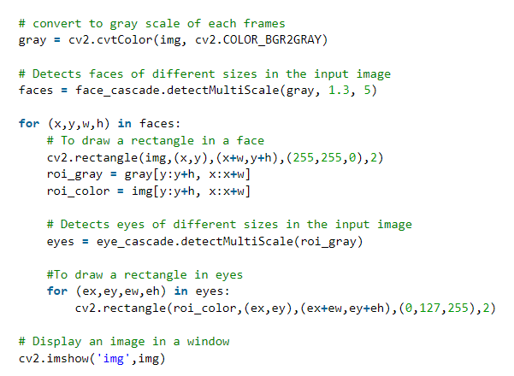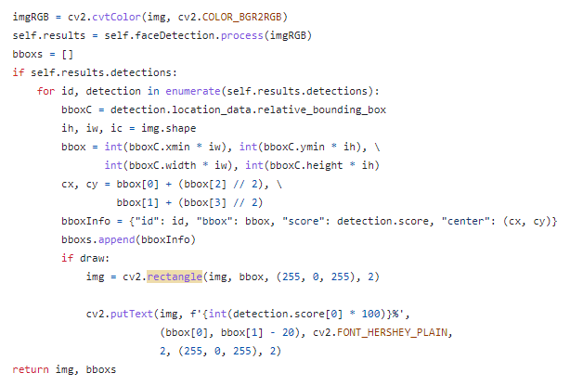

Moreover, the mapping between the 3d print component and micro-servos is also an issue we have encountered.

In order to attach the mirror plate to the servos, we drew a 3D-print component to connect them and printed it. As we were planning to move the servos directly according to the face position of the visitor, we have to map the maximum and minimum pulse values of the servos to the coordinate information generated by the face detection.

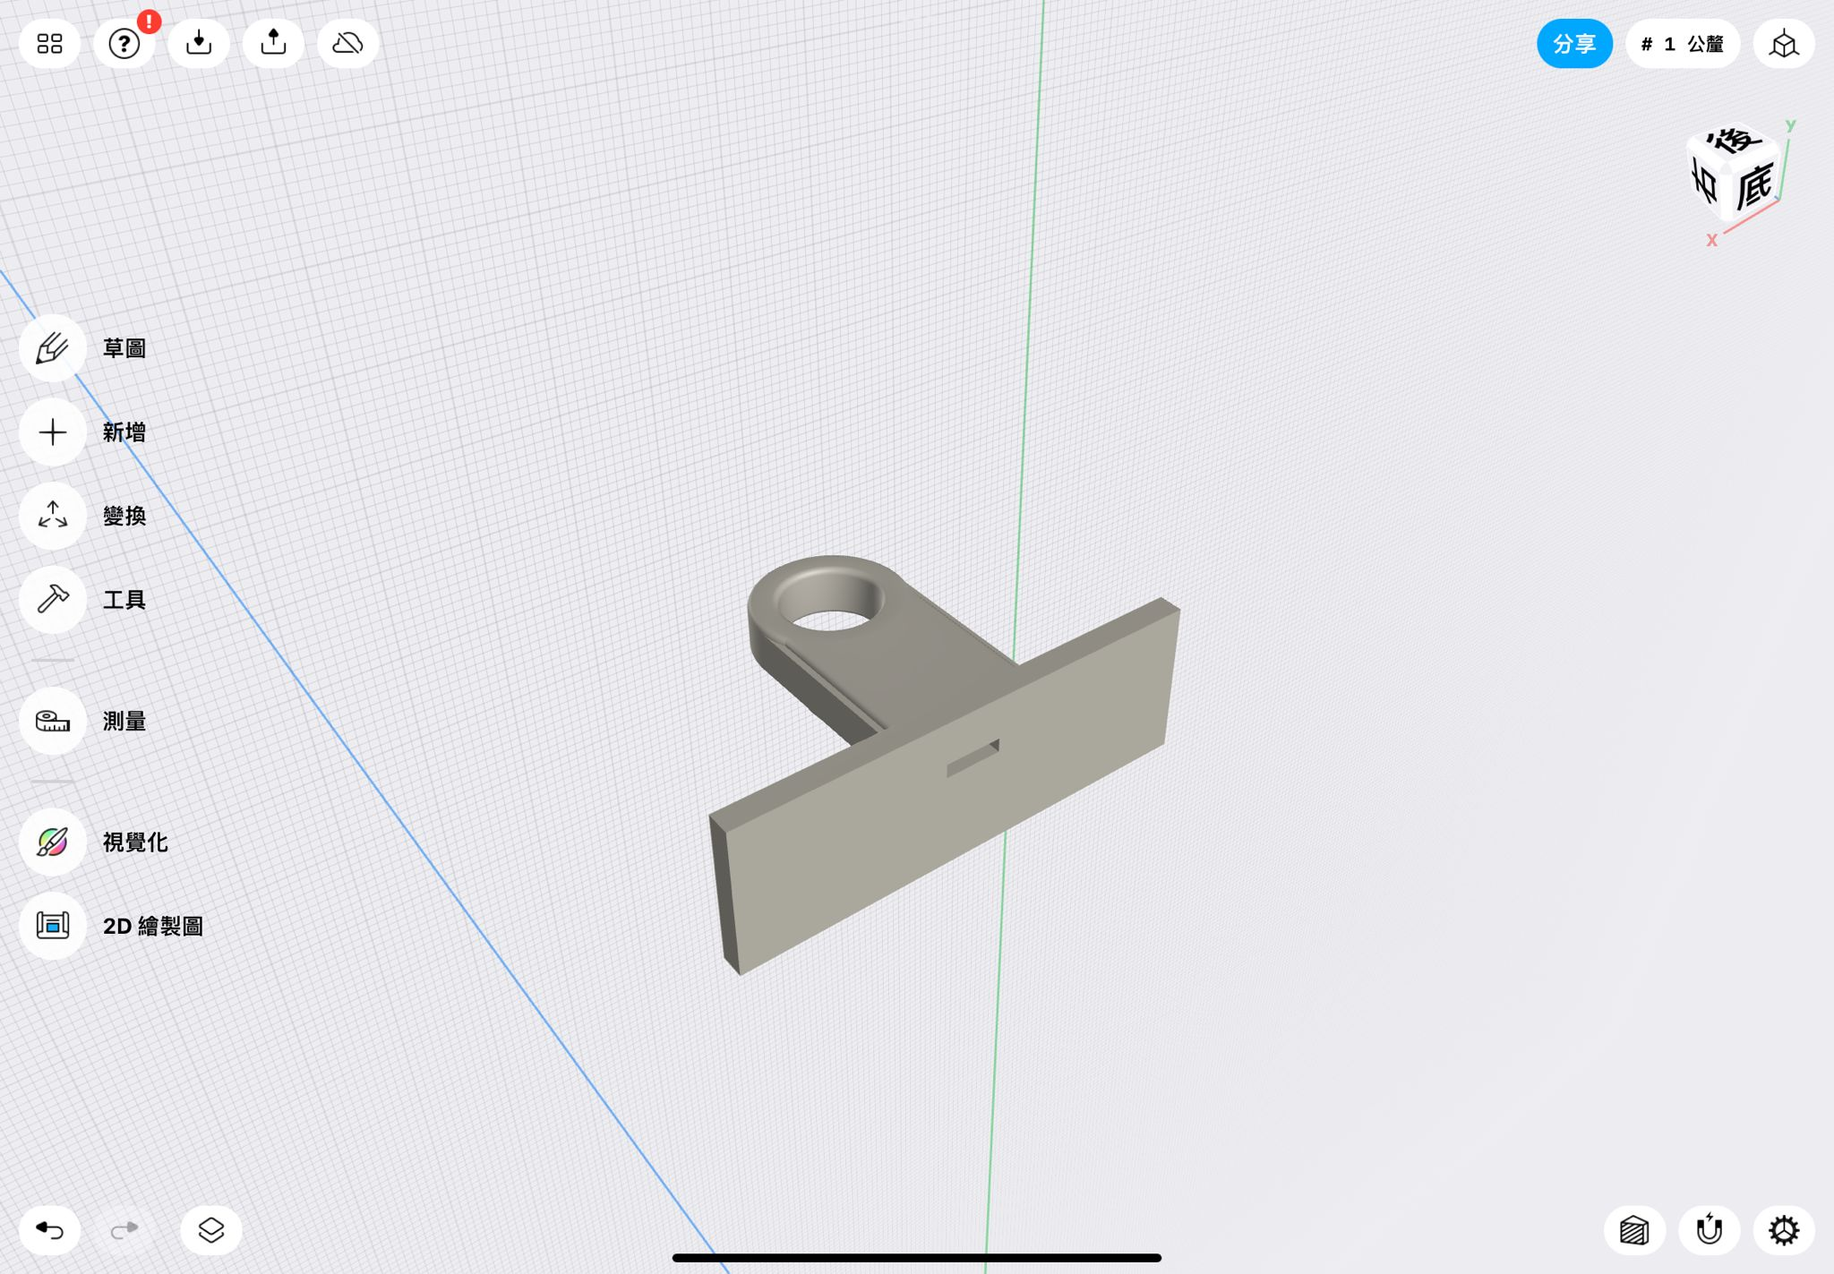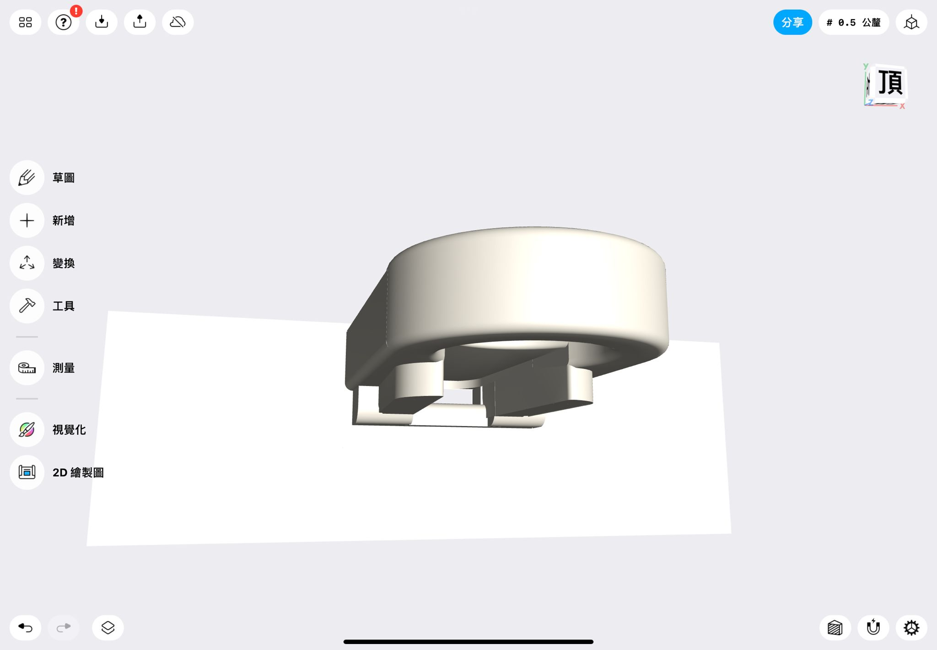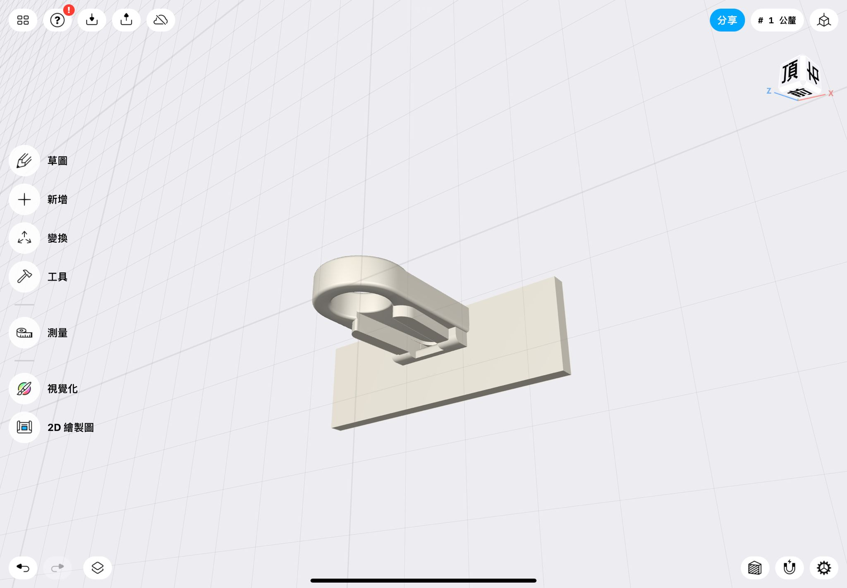

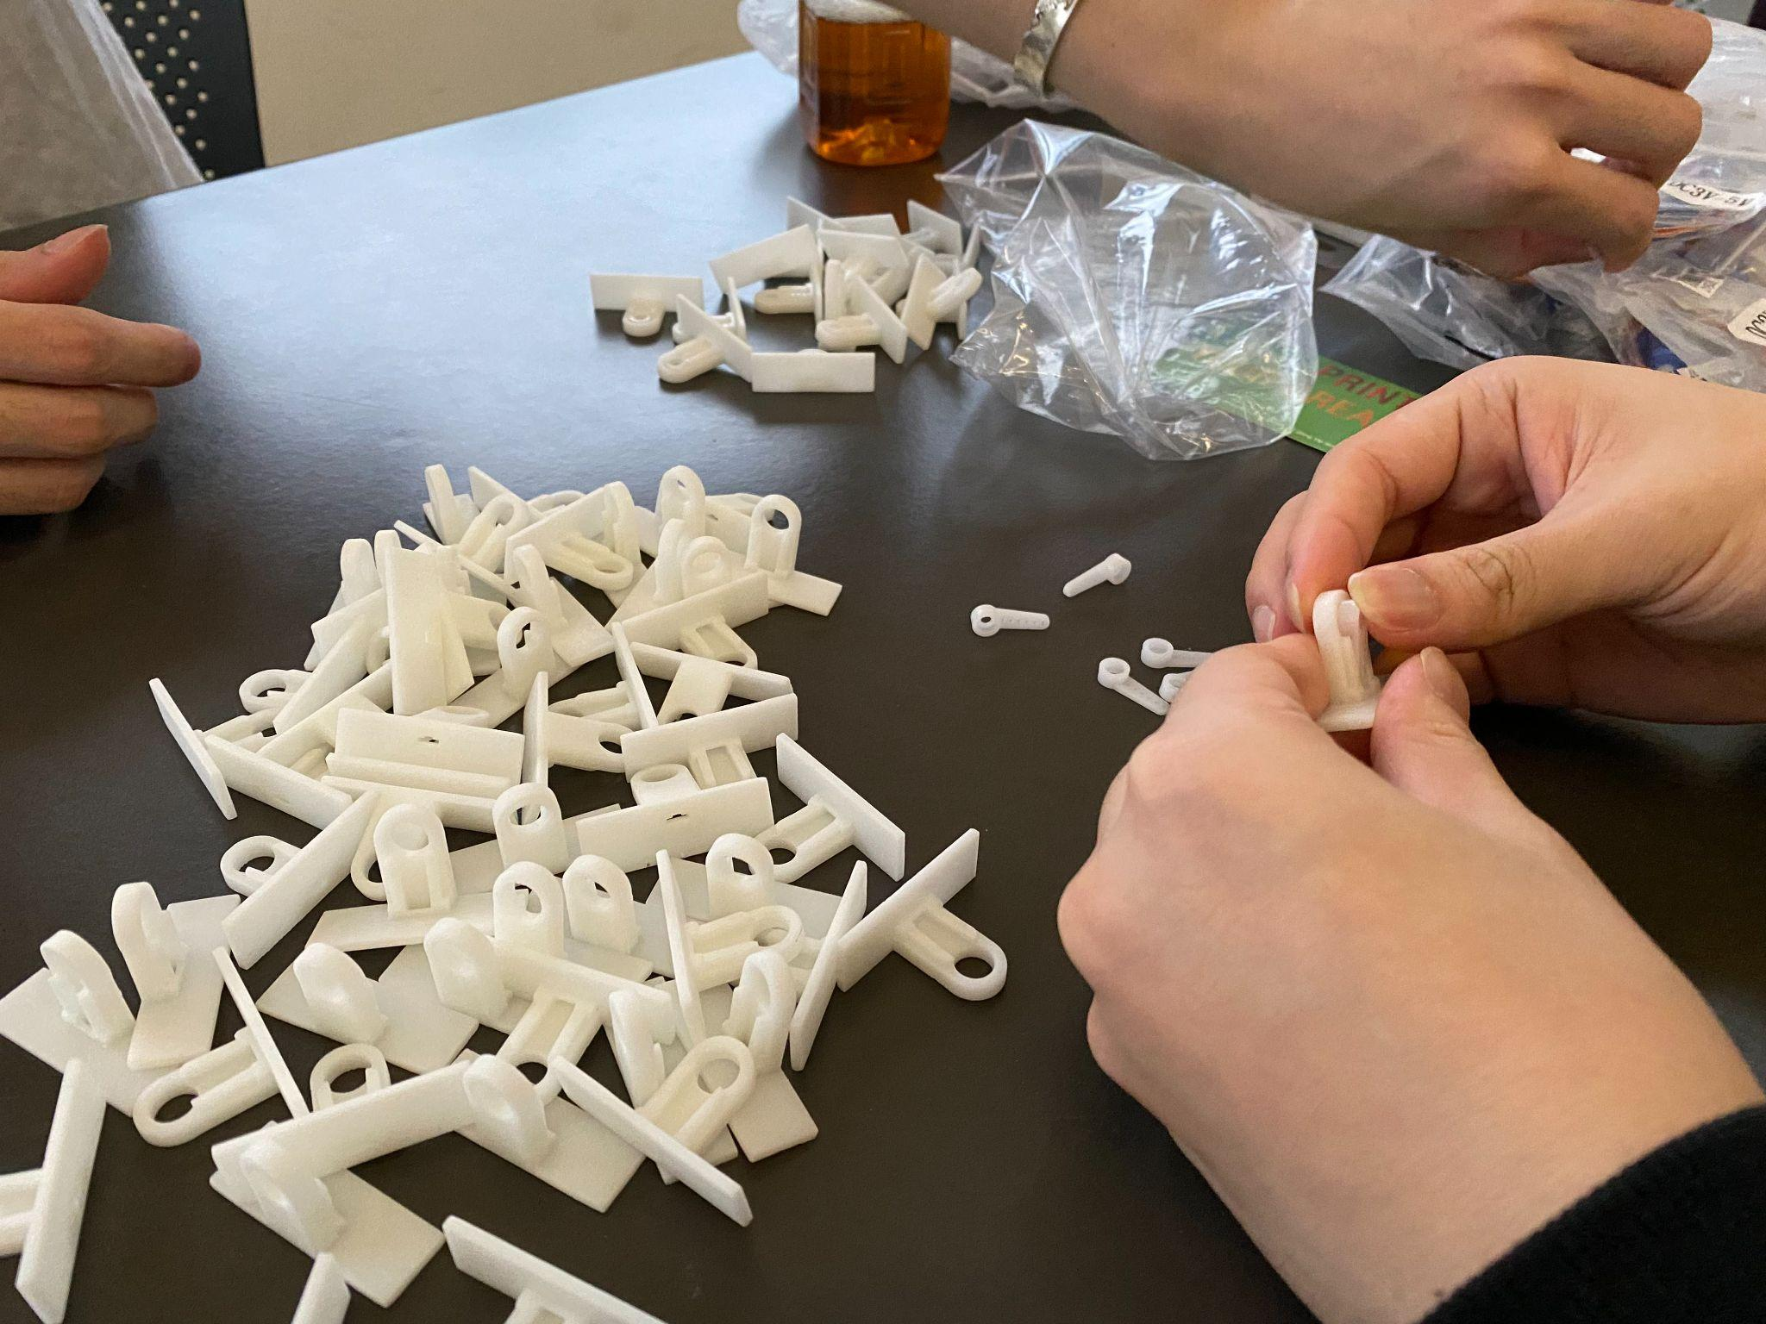

During the mapping, it is also important to find out the middle pulse value representing the neutral middle position of the detection border so that all servos will go back to it when nothing is detected. However, after the mapping, we found out that there is a deviation error on some servos that make them a few degrees away from the plane and neutral position. Deviation is a very common and minor error but when it comes to the plane view of successive mirror plates, it becomes noticeable.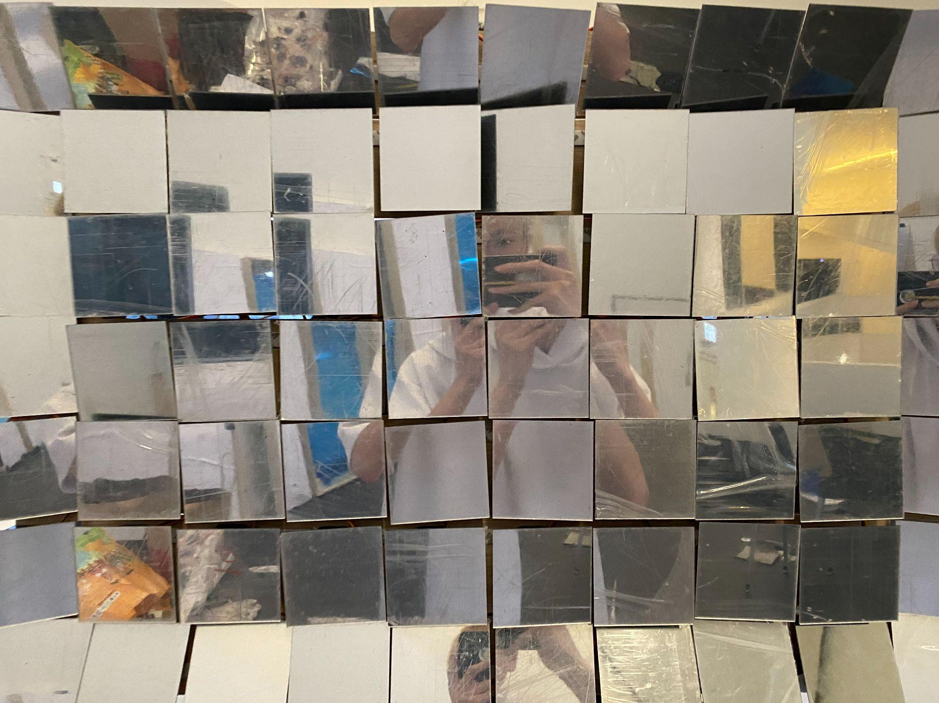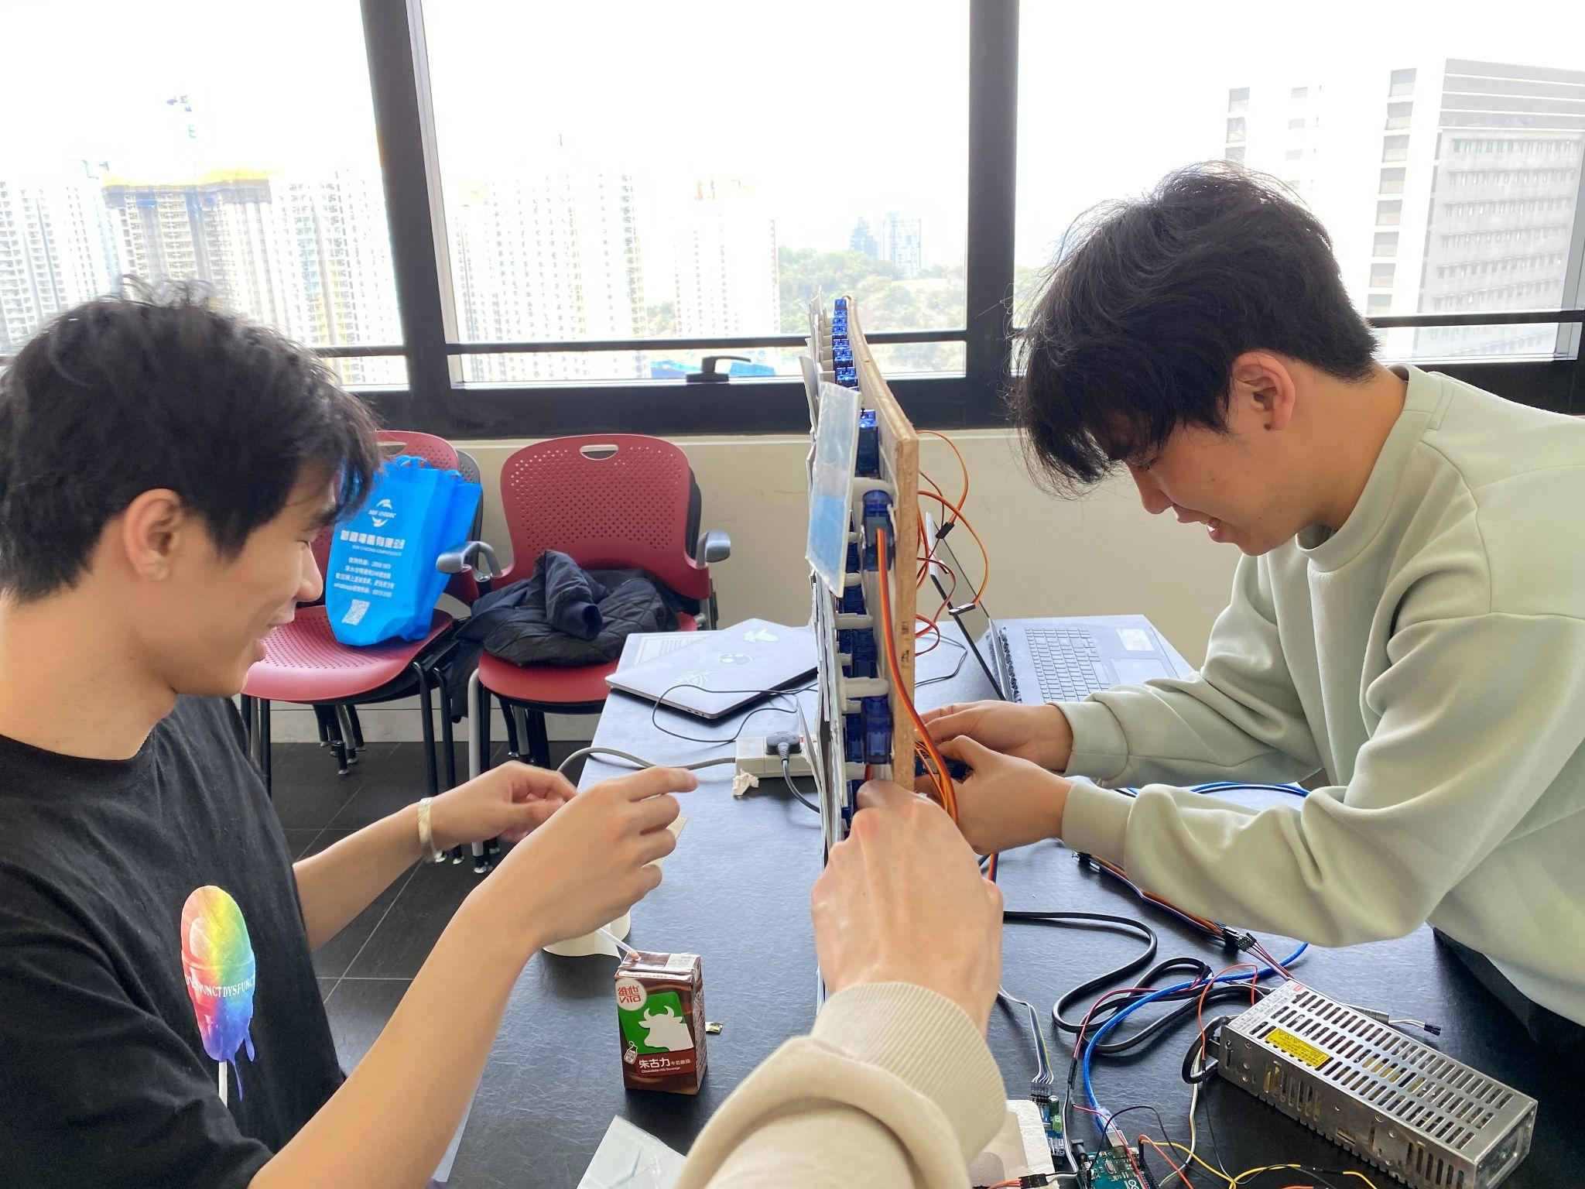

Last but not least, controlling up to 70 servos requires a lot of power.

We are using the micro SG90 servos in our projects which are basically 3/4.8-6v tolerate.However, as we are controlling the servos with a real time interactive application, they basically move every millisecond such that each micro servos may consume up to 250mA, 70x250=17500mA=17.5A . As a result, we need to buy a power supply with 5v but high current supply which can provide 20+-A.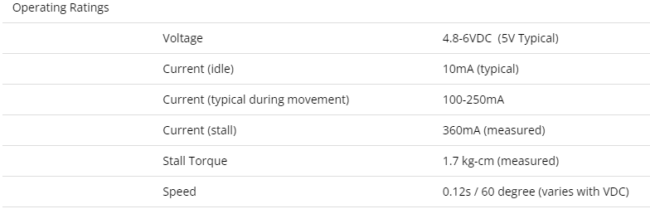

# 

# **Concluding remarks: A critical appraisal of the project**

Although our works have basically achieved our original goal and the effect has basically reached our pursuit. But there is still can be more improvement, and there are subjective problems and situations that cannot be solved objectively.

First of all, on the subjective level, we did not have enough time. Even though it took two weeks to produce, we encountered many difficulties, which led to the deadline is urgent and need to speed up the production. This is where time management can improve. And our lack of understanding of those materials and servo led to buying many extra ones. Also we need to try different methods but finding that they did not help solve the problem, it is wasting time.

Objectively, the installation lacks funds, because we use a large number of materials which are special orders, so the basic cost is high. At the same time, it is objectively impossible to achieve the top quality. Clear mirrors and thick wood are expensive. We can only achieve the current production without funds. This makes the mirror paper maybe not clear enough and the wood is easily damaged.

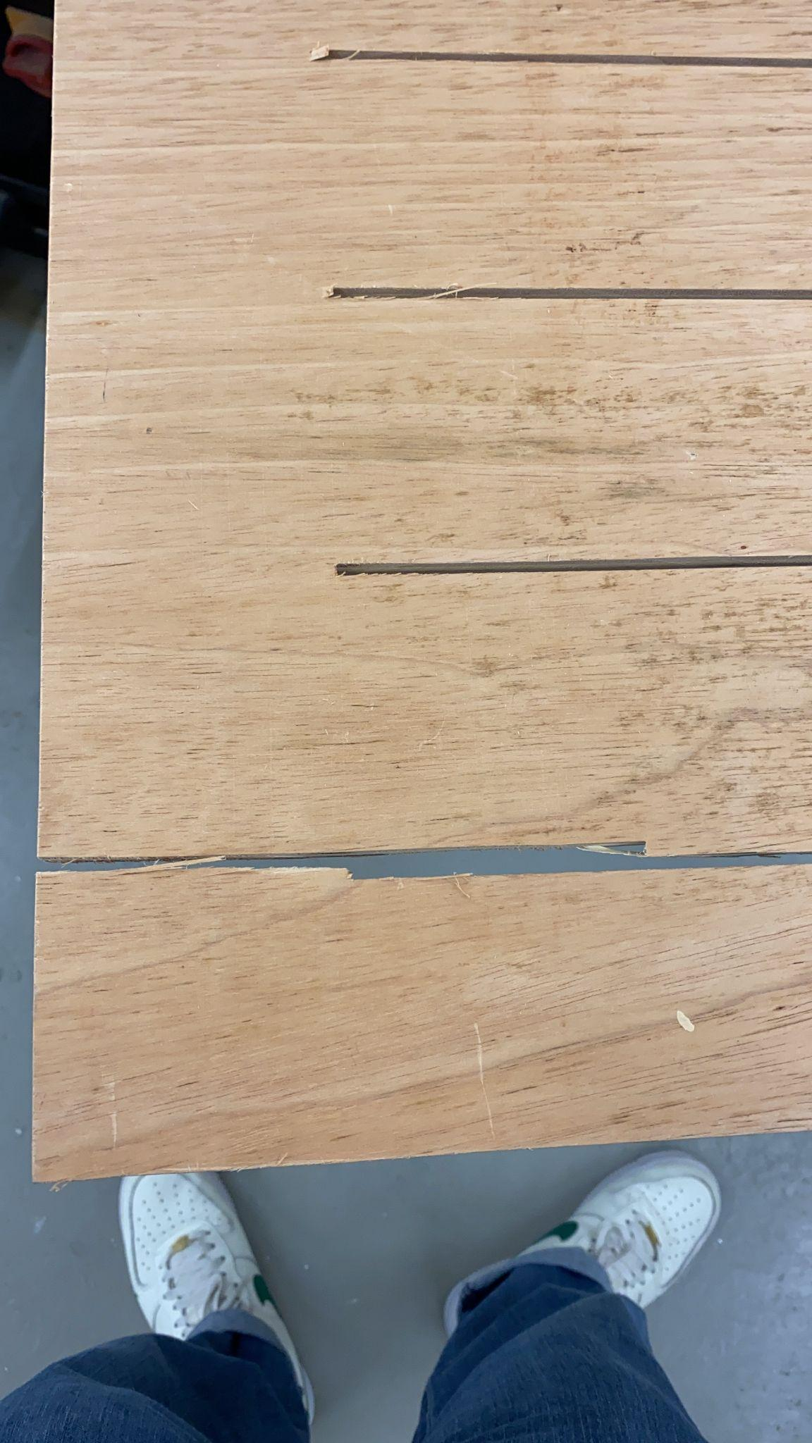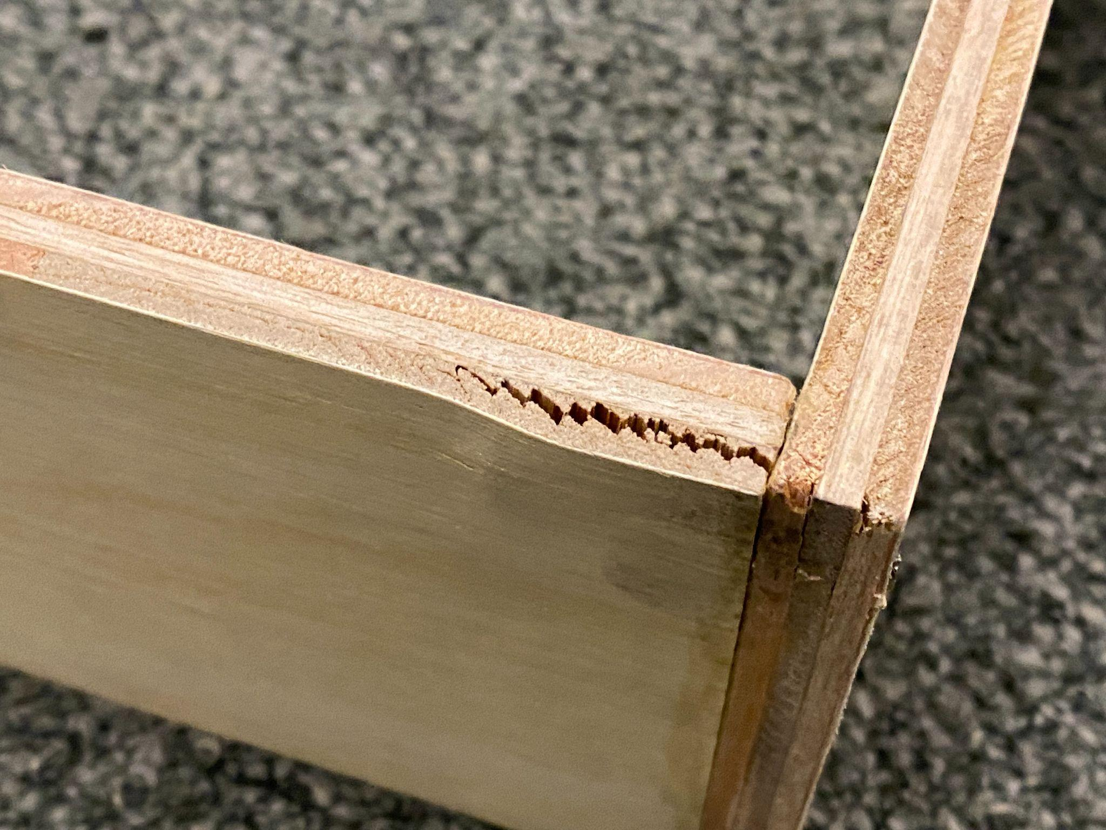

**Summary**

Even if the completed installation is not in the most ideal form, we can finally achieve the expected installation and bring visitors the message of self-reflection and find the real themselves through the installation. Through this work, we produce different mirrors to others and it is also a mirror for our group to continuously improve ourselves.

# **Acknowledgements**

We appreciate our advisors, Koala and Ricky, for the constructive feedback on our idea and how to present our installation in a better way. Your advice enhance the completeness of our project. We learned a lot in terms of how to build artwork from scratch, how to present our concept, etc. We are grateful to SCM and CS department for the equipment support and the literature we found in CityU library's search engine.

# **References/Appendices**

1. Newsroom. (2017, December 13). *Es devlin, room 2022*. Scenography Today. Retrieved December 9, 2022, from https://www.scenographytoday.com/es-devlin-room-2022/
2. Wu, A. (2016, December 2). *New Oslo installation reflects Norwegian landscape in miniature*. ArchDaily. Retrieved December 9, 2022, from https://www.archdaily.com/800175/new-oslo-installation-reflects-norwegian-landscape-in-miniature?ad_medium=gallery
3. Queue-it. (n.d.). Retrieved December 9, 2022, from https://www.mplus.org.hk/en/exhibitions/yayoi-kusama-1945-to-now/
4. *青少年学生自我意识发展的研究*. (n.d.). Retrieved December 9, 2022, from http://file.snnu.net/res/20126/30/988f24b8-91bd-4d66-8839-a08000b3ab93.pdf
5. Tseng, C. C., Chen, H. C., Chang, L. Y., Hu, J. F., & Chen, S. Y. (n.d.). *A corpus-based analysis of radical position and the degree of freedom of permissible positions and examination of the influential radical properties*. National Cheng Kung University. Retrieved December 9, 2022, from https://researchoutput.ncku.edu.tw/en/publications/a-corpus-based-analysis-of-radical-position-and-the-degree-of-fre
6. 科技新報 (2022, May 18). *青少年自我認同出問題 手機自拍如哈哈鏡: 聯合新聞網*. 雜誌. Retrieved December 9, 2022, from https://udn.com/news/story/6897/6321507
7. *Vanishing reflection ... • artwork • studio Olafur Eliasson*. Studio Olafur Eliasson. (n.d.). Retrieved December 19, 2022, from https://olafureliasson.net/archive/artwork/WEK108424/vanishing-reflection-circular-fade-out#slideshow
8. Servo Motor Data : https://protosupplies.com/product/servo-motor-micro-sg90/

1. Cv Zone, FaceDetectionMordule:https://github.com/cvzone/cvzone/blob/master/cvzone/FaceDetectionModule.py

10.Face Detection using Haar Cascades:

https://docs.opencv.org/3.4/d2/d99/tutorial_js_face_detection.html

11.Serial communication reference:

https://forum.arduino.cc/t/serial-input-basics-updated/382007

**Appendices: Relevant information listing all support material**